Hospital Management System
ABSTRACT
Our project Hospital Management system is about registration of patients, storing details of patients into the system and booking appointments of them with doctors. In our software gives unique id forever patient and stores the data of every patient and the staff automatically. User will be able to search availability of a doctor and patient detail using id. The entry point of the Hospital Management System is login using username and password. This all information is accessible by an administrator or receptionist and they can add data into database. The data can be retrieved easily. The interface is very user-friendly. The data processing is very fast and well protected for personal use. It is having mainly two modules, one is at Administration and user, i.e., of patients and doctors. The Application maintains authentication in order to access the application. Administrator task includes managing doctors information, patient’s information. To achieve this, aim a database was designed for patient and other is for doctor which is the admin can access. The user complaints are referred by authorities. The Patient modules include checking appointments, prescription.
Keywords : Hospital Management System, Patient Registration, Appointment Booking, Unique Patient ID, Doctor Availability, Authentication, Administrator Module, Patient Module, Doctor Module, Database Management, User-Friendly Interface, Secure Data Processing

INTRODUCTION

The hospital management system contains computerized patient registration, sorting of their information into the system, and patient registration. The software can automatically provide a search facility for each patient and the employees. It has a search feature that lets you see each availability's status. The availability of a doctor and patient information can be searched for by the user. With the use of a username and password, one can access the hospital management system. A receptionist or an administrator can access it. They alone can add data to the database. The information is simple to retrieve. The user interface is quite simple Data processing is quick and very well for personal usage. For multispecialty hospitals, the Health Board System is created to cover a variety of hospital administrative procedures. The management of hospital analysis and activity-based pricing can be increased using hospital management systems. The hospital management system enables you to grow your business and enhance productivity and work quality. The goal of the hospital management system project is to simplify all management processes, including patient registration, doctor appointments, and prescription writing. The user must go through a few registers. Time is lost because of this. Therefore, using this system will make it simple to manage everything process. Therefore, the development team are designing this system that can help both patients and hospital workers using the motivation of this scenario, which was frequently performed in hospitals. So, the stakeholders would like to have this system that makes hospitals work quickly and efficiently.

OBJECTIVE OF THE PROJECT:
- To automate patient registration and store all patient details securely in a centralized database.
- To generate a unique ID for every patient, ensuring easy identification and data retrieval.
- To manage and store doctors’ information efficiently for administrative purposes.
- To simplify the process of booking and managing appointments between patients and doctors.
- To provide quick search functionality for checking doctor availability and retrieving patient information using their ID.
- To ensure secure access through a login system using username and password, accessible only by administrators or receptionists.
LITERATURE SURVEY:
“Health Assessment Model to Identify and Control Risk Associated with Preeclampsia using IoT,”
R. Beri, M. K. Dubey, A. Gehlot, and R. Singh(2020)
Preeclampsia refers to a condition that occurs due to a sudden increase in Blood Pressure during 20 weeks of pregnancy. Preeclampsia may lead to the damage of some other organs of the body liver or kidneys or leads to the occurrence of brain stroke or seizures. It occurs in 15 to 20 women in 100 and becomes a significant reason for maternal mortality or infant loss. It is necessary to prevent the risks related to preeclampsia by monitoring the health parameters of the patient in a real-time environment. The risk assessment model, when amalgamating with IoT and other related technologies, offers intelligent solutions to monitor health parameters in a real-time environment. The present study is focusing on proposing an IoT based health assessment framework to capture the blood pressure and other health-related parameters of pregnant women continuously. The captured data is then processed and analyzed by fog nodes. These fog nodes then provide real-time suggestions to the patient for improving health conditions. Moreover, the fog nodes also send the processed data to cloud servers for further analysis by healthcare providers.
“Application of multi-layer neural network in medical diagnosis: An efficient survey,”
Rana, A. S. Rawat, H. Bahuguna, and A. Bijalwan,(2018)
A enormous extent of facts is presently accessible to medical proficient; diverge from information of medical signs to a assortment of varieties of biological facts as well as imaging machines' results. All kind of facts gives statistics that which is assessed as well as allocated for exacting pathology throughout the investigative procedure. For restructuring the analytical procedure on a day-to-day basis practice and evade misdiagnosis, artificial intelligence techniques (artificial neural networks, computer aided diagnosis) are able to employ. These adaptive learning techniques could be hold different kinds of medicinal facts and amalgamate them into characterized outcomes. In this paper, we have concisely analyzed and deliberated about competencies, philosophy as well as restrictions of ANN in medicinal analysis concluded elected paradigms.
“Elucidative analysis and sequencing of two respiratory health monitoring methods to study the impact of varying atmospheric composition on human health,”
Awasthi, N. Hothi, P. Kaur, N. Singh, M. Chakraborty, and S. Bansal,(2017)
Atmospheric composition of ambient air consists of different gases in definite proportion that affect the earth's climate and its ecological system. Due to varied anthropogenic reasons, this composition is changed, which ultimately have an impact on the health of living beings. For survival, the human respiratory system is one of the sensitive systems, which is easily and closely affected by the change in atmospheric composition of an external environment. Many studies have been conducted to quantify the effects of atmospheric pollution on human health by using different approaches. This article presents different scenario of studies conducted to evaluate the effects on different human groups. Differences between the studies conducted using spirometry and survey methods are presented in this article to extract a better sequence between these two methodologies. Many studies have been conducted to measure the respiratory status by evaluating the respiratory symptoms and hospital admissions. Limited numbers of studies are found with repeated spirometry on the same subjects for long duration to nullify the error arising due to decrease in efforts by the same subjects during manoeuvre of pulmonary function tests. Present study reveals the importance of methodological sequencing in order to obtain more authentic and reliable results. This study suggests that impacts of deteriorating atmospheric composition on human health can be more significantly studied if spirometry is done after survey analysis. The article also proposes that efficiency and authenticity of surveys involving health impacts will increase, if medical data information of patients is saved in hospitals in a proper format.
“An adaptive and flexible brain energized full body exoskeleton with iot edge for assisting the paralyzed patients”
S. Jacob al(2020)
The paralyzed population is increasing worldwide due to stroke, spinal code injury, post-polio, and other related diseases. Different assistive technologies are used to improve the physical and mental health of the affected patients. Exoskeletons have emerged as one of the most promising technology to provide movement and rehabilitation for the paralyzed. But exoskeletons are limited by the constraints of weight, flexibility, and adaptability. To resolve these issues, we propose an adaptive and flexible Brain Energized Full Body Exoskeleton (BFBE) for assisting the paralyzed people. This paper describes the design, control, and testing of BFBE with 15 degrees of freedom (DoF) for assisting the users in their daily activities. The flexibility is incorporated into the system by a modular design approach. The brain signals captured by the Electroencephalogram (EEG) sensors are used for controlling the movements of BFBE. The processing happens at the edge, reducing delay in decision making and the system is further integrated with an IoT module that helps to send an alert message to multiple caregivers in case of an emergency. The potential energy harvesting is used in the system to solve the power issues related to the exoskeleton. The stability in the gait cycle is ensured by using adaptive sensory feedback. The system validation is done by using six natural movements on ten different paralyzed persons. The system recognizes human intensions with an accuracy of 85%. The result shows that BFBE can be an efficient method for providing assistance and rehabilitation for paralyzed patients.
“Bringing iot and cloud computing towards pervasive healthcare”
IliasMaglogiannis CharalamposDoukas(2012)
Pervasive healthcare applications utilizing body sensor networks generate a vast amount of data that need to be managed and stored for processing and future usage. Cloud computing among with the Internet of Things (IoT) concept is a new trend for efficient managing and processing of sensor data online. This paper presents a platform based on Cloud Computing for management of mobile and wearable healthcare sensors, demonstrating this way the IoT paradigm applied on pervasive healthcare.
“SMART Hospital Management Systems Based on the Internet of Things:”
Dalia Kamal A. A. Rizk, Hoda M. Hosny, and El-Sayed M. El-Horbaty(2021)
Nowadays, Internet of Things (IoT) is invading almost all sectors of life since it is based on connecting living or non-living things together through computer technology. It is responsible for connecting physical objects together through the internet. Healthcare and hospitals are one of the most important sectors that require a lot of attention to transfer their old form of documentation into SMART management systems. It is essential to analyze health data in order to increase the quality of patient’s care. Egypt being a development country is starting to substitute its old governmental systems into electronic SMART technology. IoT devices produce different types of data and transfer them to the cloud computing for storage and analysis. The benefits of using IoT in collecting, transferring, and analyzing patients’ data for the hospitals are attracting a lot of researchers. Therefore, the arrangement of smarter and more money saving healthcare services are becoming highly required. Security and privacy, device communication, and data collection and management are some of the challenges that face the IoT technology especially when used with hospital’s data. Accordingly, a proposed reference model for making SMART hospital management system is under construction in order to achieve the best performance. The model is taking into consideration both the functional and non-functional requirements of the different participants involved in the hospital management system.
“Cognitive Smart Healthcare for Pathology Detection and Monitoring,”
M. Alhussein, G. Muhammad, M S. Hossain, SU. Amin, and A. Rahman,(2019)
We propose a cognitive healthcare framework that adopts the Internet of Things (IoT)-cloud technologies. This framework uses smart sensors for communications and deep learning for intelligent decision-making within the smart city perspective. The cognitive and smart framework monitors patients' state in real time and provides accurate, timely, and high-quality healthcare services at low cost. To assess the feasibility of the proposed framework, we present the experimental results of an EEG pathology classification technique that uses deep learning. We employ a range of healthcare smart sensors, including an EEG smart sensor, to record and monitor multimodal healthcare data continuously. The EEG signals from patients are transmitted via smart IoT devices to the cloud, where they are processed and sent to a cognitive module. The system determines the state of the patient by monitoring sensor readings, such as facial expressions, speech, EEG, movements, and gestures. The real-time decision, based on which the future course of action is taken, is made by the cognitive module. When information is transmitted to the deep learning module, the EEG signals are classified as pathologic or normal. The patient state monitoring and the EEG processing results are shared with healthcare providers, who can then assess the patient's condition and provide emergency help if the patient is in a critical state. The proposed deep learning model achieves better accuracy than the state-of-the-art systems.
“Advanced Hospital Database Management System”
Gunjan Yadav, Parth Lad, Parul Pandey, Tejaswi K(2021)
Human Body is an extremely intricate and modern structure and involves a huge number of capacities. All these muddled capacities have been comprehended by man him, part-by-part their exploration and tests. As science and innovation advanced, pharmaceutical turned into a necessary part of the exploration. Continuously, restorative science turned into an altogether new branch of science. Starting today, the Health Sector involves Medical establishments i.e. Healing facilities, HOSPITALs and so forth innovative work foundations and medicinal universities. In this way the Health division goes for giving the best therapeutic offices to the basic man.
SYSTEM ANALYSIS
EXISTINGSYSTEM:
Traditional hospital management systems rely on manual or semi-automated processes for user registration, document handling, and identity verification. Aadhar card data is manually input and vulnerable to human error or misuse. There’s limited or no automated mechanism for securely managing sensitive patient data, especially in terms of masking personal identifiers.
Disadvantages:
- Manual data entry can lead to errors and inconsistencies.
- No privacy mechanism to protect sensitive Aadhar information.
- Delayed processing and coordination between patients, doctors, and insurance users.
PROPOSED SYSTEM:
The proposed system automates hospital management using YOLOv11-based Aadhar card detection and OCR to extract Aadhar numbers securely. It includes role-based logins for patients, doctors, insurance agents, and admins, ensuring data privacy through masking and unmasking of sensitive data, along with automated profile creation, appointment booking, document upload, prescription management, and billing.
Advantages:
- Automated Aadhar detection and OCR ensures fast and accurate data extraction.
- Role-based masking/unmasking provides better privacy control for sensitive data.
- Seamless integration of appointments, prescriptions, and billing improves overall efficiency.
System Architecture:

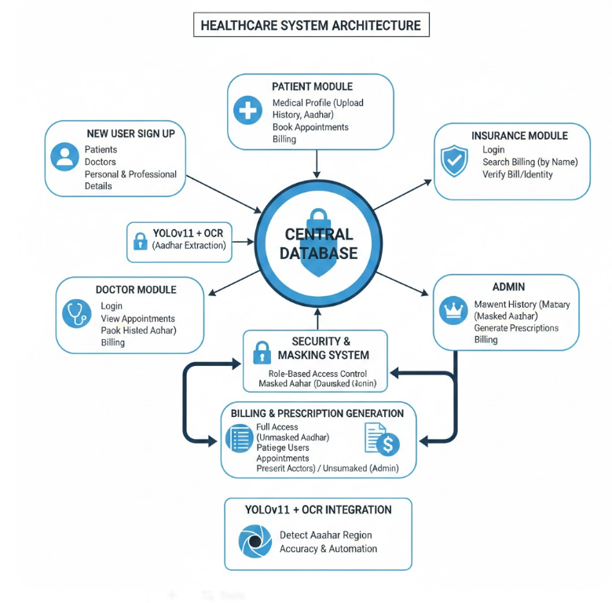
Module description:
To implement this project we have designed following modules
- New User Sign Up
  - Allows new users (Patients, Doctors, Insurance Agents) to register with the system by entering their personal and professional details. These details are stored in the database for future login and access.
- Patient Module
  - Patients can log in, create their medical profile by uploading medical history documents and an Aadhar card.
  - The system uses YOLOv11 to detect the Aadhar card number region and applies OCR to extract the number.
  - Extracted Aadhar data is masked when viewed by doctors and unmasked only for admin.
  - Patients can view available doctors, book appointments, and access their prescriptions and billing details.
- Doctor Module
  - Doctors can log in and view appointments scheduled for the current day.
  - They can view patient history, download uploaded documents, and generate prescriptions.
  - Aadhar card numbers are shown in a masked format for privacy.
- Insurance Module
  - Insurance company users can log in and search billing details by entering patient names.
  - They can verify the bill amount and patient identity without accessing full sensitive data.
- Admin Module
  - Admins can log in and view all user profiles, appointments, prescriptions, and billing records.
  - Admins have full access, including viewing unmasked Aadhar cards and managing system-wide data.
- YOLOv11 + OCR Integration
  - Integrates the YOLOv11 CNN algorithm to detect the Aadhar number region in uploaded cards.
  - Optical Character Recognition (OCR) is then applied to extract the number for storage and further verification.
  - This ensures accuracy and automates the verification process securely.
- Billing & Prescription Generation
  - Once a doctor creates a prescription, an automated bill is generated for the patient.
  - These can be accessed by both the patient and insurance users for verification and processing.
- Security and Masking System
  - Implements role-based access control where sensitive Aadhar card numbers are masked for doctors and unmasked only for admins.
  - Ensures privacy and data protection in compliance with healthcare data policies.
PROCESS MODEL USED WITH JUSTIFICATION
SDLC (Umbrella Model):
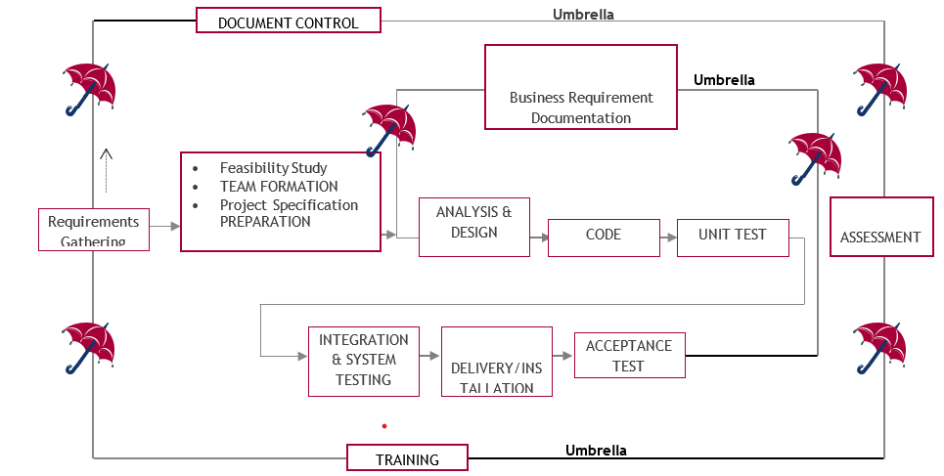
SDLC is nothing but Software Development Life Cycle. It is a standard which is used by software industry to develop good software.
Stages in SDLC:
- Requirement Gathering
- Analysis
- Designing
- Coding
- Testing
- Maintenance
Requirements Gathering stage:
The requirements gathering process takes as its input the goals identified in the high-level requirements section of the project plan. Each goal will be refined into a set of one or more requirements. These requirements define the major functions of the intended application, define operational data areas and reference data areas, and define the initial data entities. Major functions include critical processes to be managed, as well as mission critical inputs, outputs and reports. A user class hierarchy is developed and associated with these major functions, data areas, and data entities. Each of these definitions is termed a Requirement. Requirements are identified by unique requirement identifiers and, at minimum, contain a requirement title and textual description.
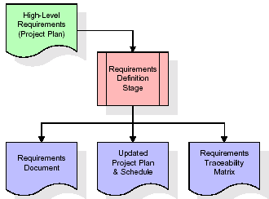
These requirements are fully described in the primary deliverables for this stage: the Requirements Document and the Requirements Traceability Matrix (RTM). The requirements document contains complete descriptions of each requirement, including diagrams and references to external documents as necessary. Note that detailed listings of database tables and fields are not included in the requirements document.
The title of each requirement is also placed into the first version of the RTM, along with the title of each goal from the project plan. The purpose of the RTM is to show that the product components developed during each stage of the software development lifecycle are formally connected to the components developed in prior stages.
In the requirements stage, the RTM consists of a list of high-level requirements, or goals, by title, with a listing of associated requirements for each goal, listed by requirement title. In this hierarchical listing, the RTM shows that each requirement developed during this stage is formally linked to a specific product goal. In this format, each requirement can be traced to a specific product goal, hence the term requirements traceability.
The outputs of the requirements definition stage include the requirements document, the RTM, and an updated project plan.
- Feasibility study is all about identification of problems in a project.
- No. of staff required to handle a project is represented as Team Formation, in this case only modules are individual tasks will be assigned to employees who are working for that project.
- Project Specifications are all about representing of various possible inputs submitting to the server and corresponding outputs along with reports maintained by administrator.
Analysis Stage:
The planning stage establishes a bird's eye view of the intended software product, and uses this to establish the basic project structure, evaluate feasibility and risks associated with the project, and describe appropriate management and technical approaches.
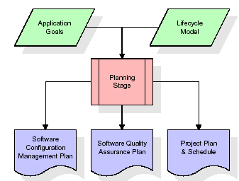
The most critical section of the project plan is a listing of high-level product requirements, also referred to as goals. All of the software product requirements to be developed during the requirements definition stage flow from one or more of these goals. The minimum information for each goal consists of a title and textual description, although additional information and references to external documents may be included. The outputs of the project planning stage are the configuration management plan, the quality assurance plan, and the project plan and schedule, with a detailed listing of scheduled activities for the upcoming Requirements stage, and high level estimates of effort for the out stages.
Designing Stage:
The design stage takes as its initial input the requirements identified in the approved requirements document. For each requirement, a set of one or more design elements will be produced as a result of interviews, workshops, and/or prototype efforts. Design elements describe the desired software features in detail, and generally include functional hierarchy diagrams, screen layout diagrams, tables of business rules, business process diagrams, pseudo code, and a complete entity-relationship diagram with a full data dictionary. These design elements are intended to describe the software in sufficient detail that skilled programmers may develop the software with minimal additional input.
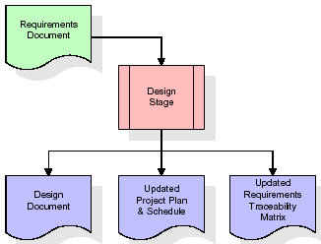
When the design document is finalized and accepted, the RTM is updated to show that each design element is formally associated with a specific requirement. The outputs of the design stage are the design document, an updated RTM, and an updated project plan.
Development (Coding) Stage:
The development stage takes as its primary input the design elements described in the approved design document. For each design element, a set of one or more software artifacts will be produced. Software artifacts include but are not limited to menus, dialogs, and data management forms, data reporting formats, and specialized procedures and functions. Appropriate test cases will be developed for each set of functionally related software artifacts, and an online help system will be developed to guide users in their interactions with the software.
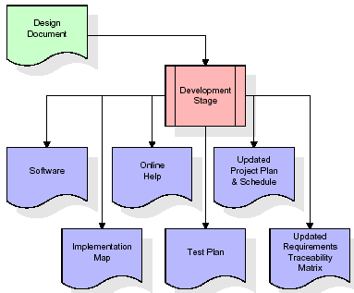

The RTM will be updated to show that each developed artifact is linked to a specific design element, and that each developed artifact has one or more corresponding test case items. At this point, the RTM is in its final configuration. The outputs of the development stage include a fully functional set of software that satisfies the requirements and design elements previously documented, an online help system that describes the operation of the software, an implementation map that identifies the primary code entry points for all major system functions, a test plan that describes the test cases to be used to validate the correctness and completeness of the software, an updated RTM, and an updated project plan.
Integration & Test Stage:
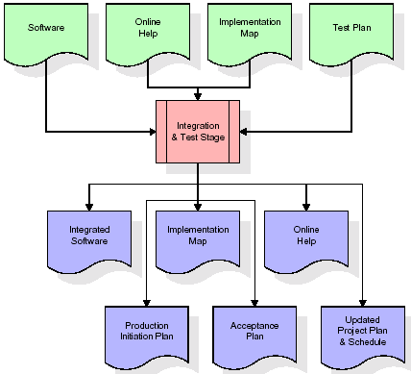
During the integration and test stage, the software artifacts, online help, and test data are migrated from the development environment to a separate test environment. At this point, all test cases are run to verify the correctness and completeness of the software. Successful execution of the test suite confirms a robust and complete migration capability. During this stage, reference data is finalized for production use and production users are identified and linked to their appropriate roles. The final reference data (or links to reference data source files) and production user list are compiled into the Production Initiation Plan.
The outputs of the integration and test stage include an integrated set of software, an online help system, an implementation map, a production initiation plan that describes reference data and production users, an acceptance plan which contains the final suite of test cases, and an updated project plan.
- Installation & Acceptance Test:
During the installation and acceptance stage, the software artifacts, online help, and initial production data are loaded onto the production server. At this point, all test cases are run to verify the correctness and completeness of the software. Successful execution of the test suite is a prerequisite to acceptance of the software by the customer.
After customer personnel have verified that the initial production data load is correct and the test suite has been executed with satisfactory results, the customer formally accepts the delivery of the software.
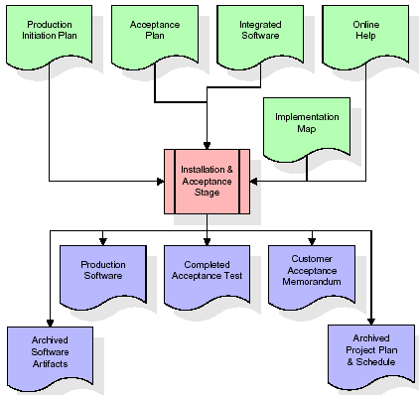
The primary outputs of the installation and acceptance stage include a production application, a completed acceptance test suite, and a memorandum of customer acceptance of the software. Finally, the PDR enters the last of the actual labor data into the project schedule and locks the project as a permanent project record. At this point the PDR "locks" the project by archiving all software items, the implementation map, the source code, and the documentation for future reference.
Maintenance:
Outer rectangle represents maintenance of a project, Maintenance team will start with requirement study, understanding of documentation later employees will be assigned work and they will undergo training on that particular assigned category. For this life cycle there is no end, it will be continued so on like an umbrella (no ending point to umbrella sticks).
Software Requirement Specification
Overall Description
A Software Requirements Specification (SRS) – a requirements specification for a software system is a complete description of the behavior of a system to be developed. It includes a set of use cases that describe all the interactions the users will have with the software. In addition to use cases, the SRS also contains non-functional requirements. Nonfunctional requirements are requirements which impose constraints on the design or implementation (such as performance engineering requirements, quality standards, or design constraints).
System requirements specification: A structured collection of information that embodies the requirements of a system. A business analyst, sometimes titled system analyst, is responsible for analyzing the business needs of their clients and stakeholders to help identify business problems and propose solutions. Within the systems development lifecycle domain, the BA typically performs a liaison function between the business side of an enterprise and the information technology department or external service providers. Projects are subject to three sorts of requirements:
- Business requirements describe in business terms what must be delivered or accomplished to provide value.
- Product requirements describe properties of a system or product (which could be one of several ways to accomplish a set of business requirements.)
- Process requirements describe activities performed by the developing organization. For instance, process requirements could specify. Preliminary investigation examine project feasibility, the likelihood the system will be useful to the organization. The main objective of the feasibility study is to test the Technical, Operational and Economical feasibility for adding new modules and debugging old running system. All system is feasible if they are unlimited resources and infinite time. There are aspects in the feasibility study portion of the preliminary investigation:
- ECONOMIC FEASIBILITY
A system can be developed technically and that will be used if installed must still be a good investment for the organization. In the economic feasibility, the development cost in creating the system is evaluated against the ultimate benefit derived from the new systems. Financial benefits must equal or exceed the costs. The system is economically feasible. It does not require any addition hardware or software. Since the interface for this system is developed using the existing resources and technologies available at NIC, There is nominal expenditure and economic feasibility for certain.
- Operational Feasibility
Proposed projects are beneficial only if they can be turned out into information system. That will meet the organization’s operating requirements. Operational feasibility aspects of the project are to be taken as an important part of the project implementation. This system is targeted to be in accordance with the above-mentioned issues. Beforehand, the management issues and user requirements have been taken into consideration. So there is no question of resistance from the users that can undermine the possible application benefits. The well-planned design would ensure the optimal utilization of the computer resources and would help in the improvement of performance status.
- TECHNICAL FEASIBILITY
Earlier no system existed to cater to the needs of ‘Secure Infrastructure Implementation System’. The current system developed is technically feasible. It is a web-based user interface for audit workflow at NIC-CSD. Thus it provides an easy access to .the users. The database’s purpose is to create, establish and maintain a workflow among various entities in order to facilitate all concerned users in their various capacities or roles. Permission to the users would be granted based on the roles specified. Therefore, it provides the technical guarantee of accuracy, reliability and security.

External Interface Requirements
User Interface
The user interface of this system is a user-friendly python Graphical User Interface.
Hardware Interfaces
The interaction between the user and the console is achieved through python capabilities.
Software Interfaces
The required software is python.
SYSTEM REQUIREMENT:
HARDWARE REQUIREMENTS:

Processor - Intel i3(min)
- Speed - 1.1 GHz
- RAM - 4GB (min)
- Hard Disk - 500 GB
SOFTWARE REQUIREMENTS:
- Operating System - Windows10(min)
- Programming Language - Python 3.7.0 with Django

SYSTEM DESIGN
UML Diagram:
The Unified Modelling Language allows the software engineer to express an analysis model using the modelling notation that is governed by a set of syntactic semantic and pragmatic rules.
A UML system is represented using five different views that describe the system from distinctly different perspective. Each view is defined by a set of diagram, which is as follows.
User Model View
- This view represents the system from the user’s perspective.
- The analysis representation describes a usage scenario from the end-user’s perspective.
Structural Model view
- In this model the data and functionality are arrived from inside the system.
- This model view models the static structures.
Behavioral Model View
It represents the dynamic of behavioral as parts of the system, depicting the interactions of collection between various structural elements described in the user model and structural model view.
Implementation Model View
In this the structural and behavioral as parts of the system are represented as they are to be built.
Environmental Model View
In these the structural and behavioral aspects of the environment in which the system is to be implemented are represented.

SYSTEM DESIGN
Class Diagram:
The class diagram is the main building block of object-oriented modeling. It is used both for general conceptual modeling of the systematic of the application, and for detailed modeling translating the models into programming code. Class diagrams can also be used for data modeling. The classes in a class diagram represent both the main objects, interactions in the application and the classes to be programmed. In the diagram, classes are represented with boxes which contain three parts:
- The upper part holds the name of the class
- The middle part contains the attributes of the class
- The bottom part gives the methods or operations the class can take or undertake

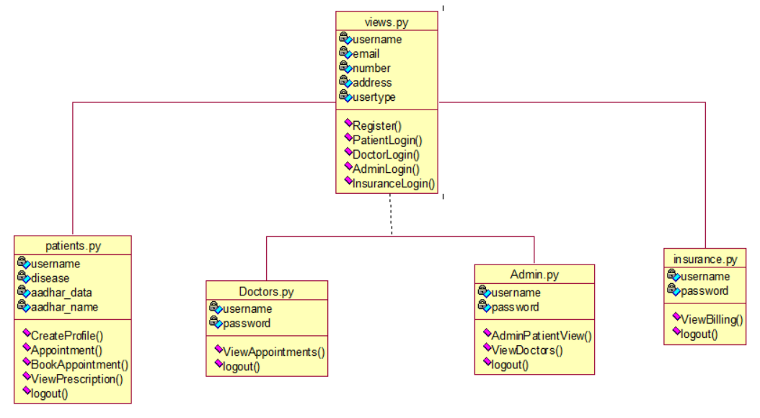
Use case Diagram:
A use case diagram at its simplest is a representation of a user's interaction with the system and depicting the specifications of a use case. A use case diagram can portray the different types of users of a system and the various ways that they interact with the system. This type of diagram is typically used in conjunction with the textual use case and will often be accompanied by other

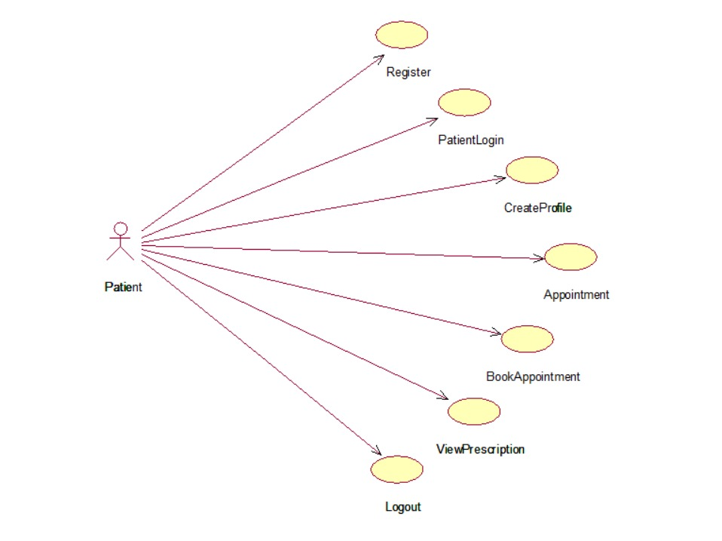
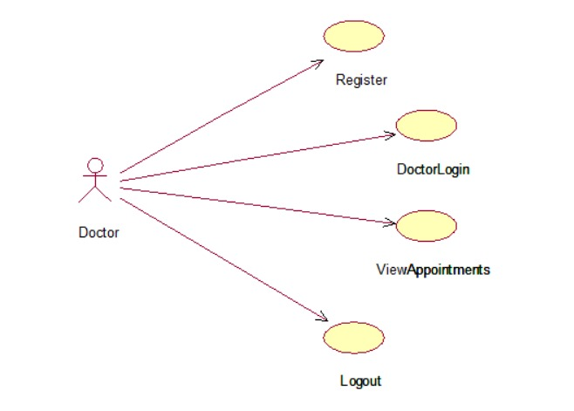
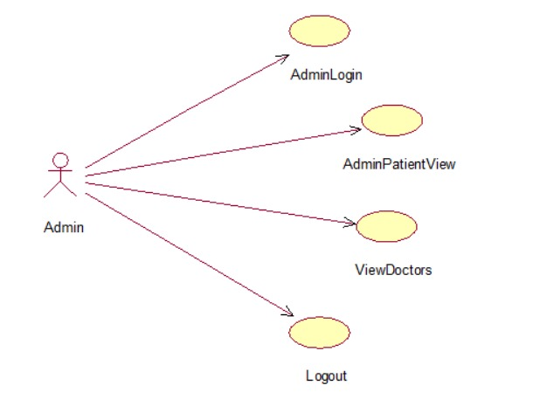
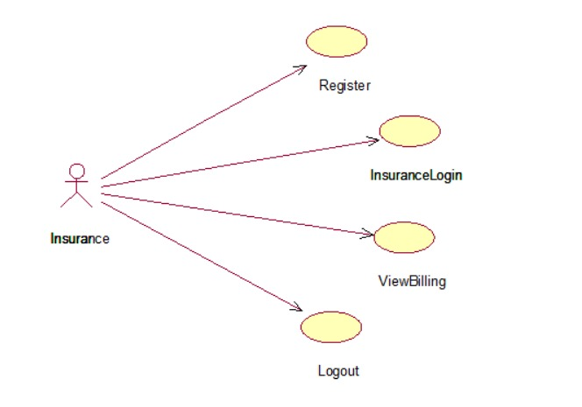
Sequence diagram:
A sequence diagram is a kind of interaction diagram that shows how processes operate with one another and in what order. It is a construct of a Message Sequence Chart. A sequence diagram shows object interactions arranged in time sequence. It depicts the objects and classes involved in the scenario and the sequence of messages exchanged between the objects needed to carry out the functionality of the scenario. Sequence diagrams are typically associated with use case realizations in the Logical View of the system under development. Sequence diagrams are sometimes called event diagrams, event scenarios, and timing diagrams.

Collaboration diagram:
A collaboration diagram describes interactions among objects in terms of sequenced messages. Collaboration diagrams represent a combination of information taken from class, sequence, and use case diagrams describing both the static structure and dynamic behaviour of a system.

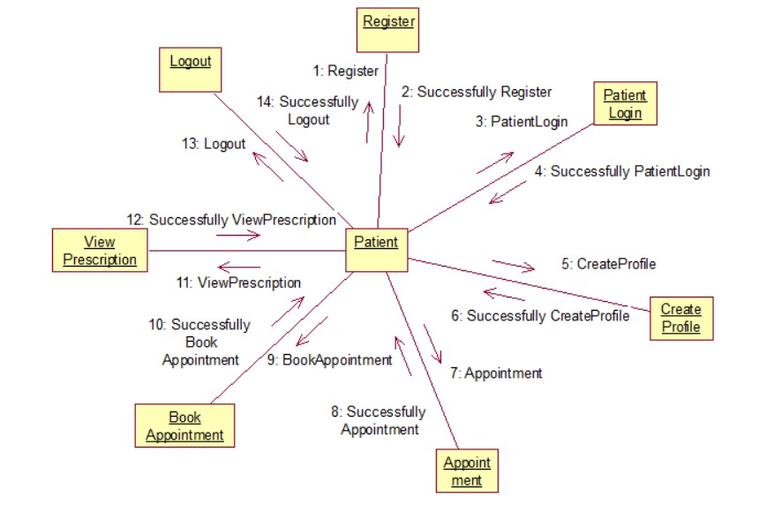
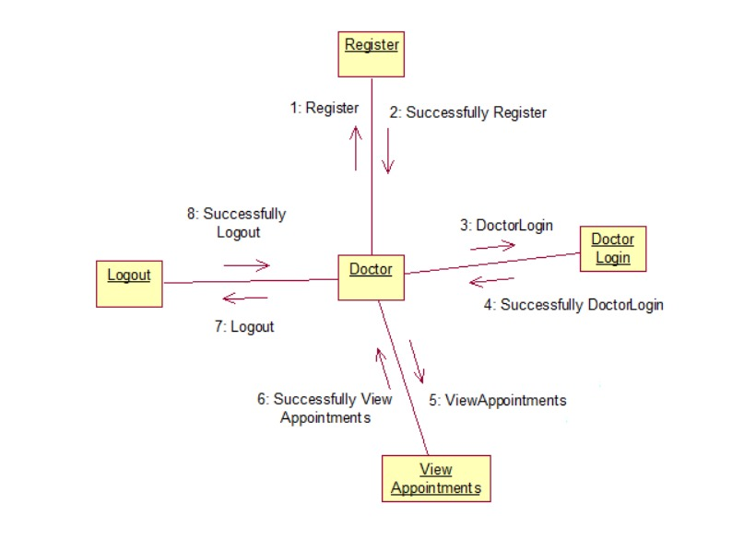
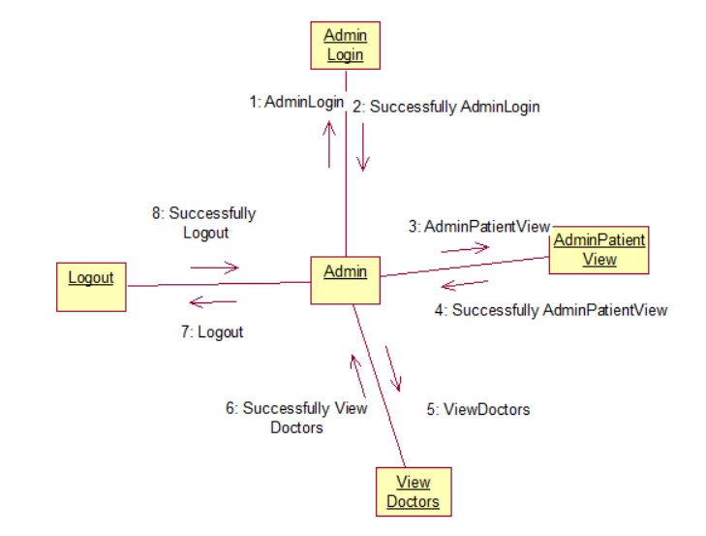
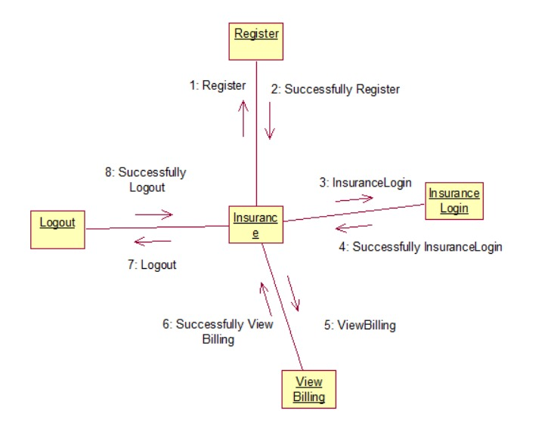
Component Diagram:
In the Unified Modelling Language, a component diagram depicts how components are wired together to form larger components and or software systems. They are used to illustrate the structure of arbitrarily complex systems.
Components are wired together by using an assembly connector to connect the required interface of one component with the provided interface of another component. This illustrates the service consumer - service provider relationship between the two components.

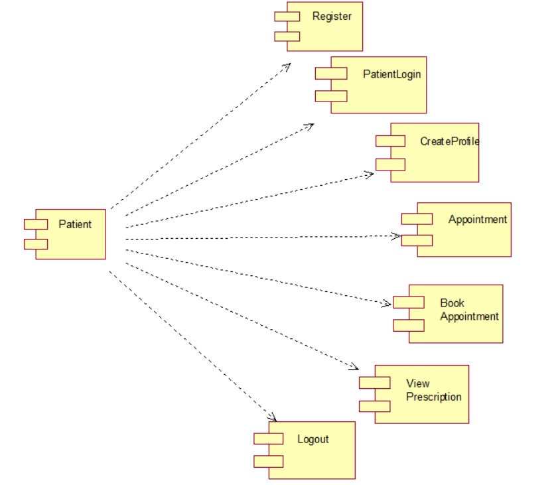
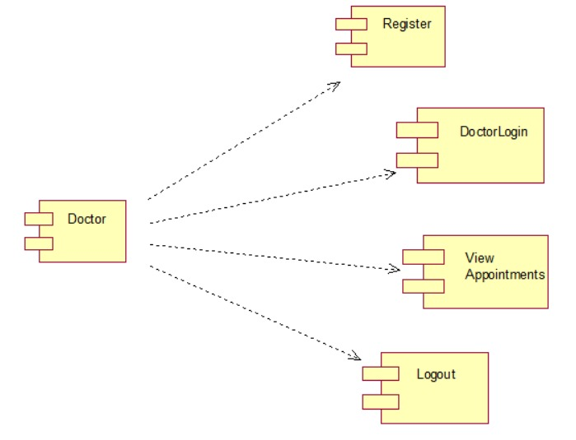
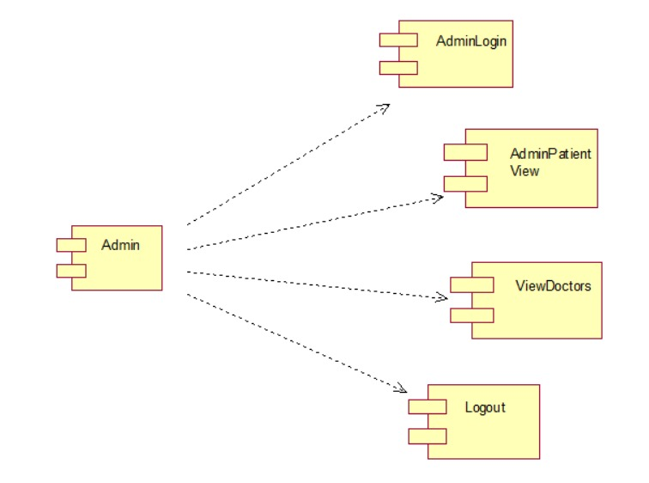
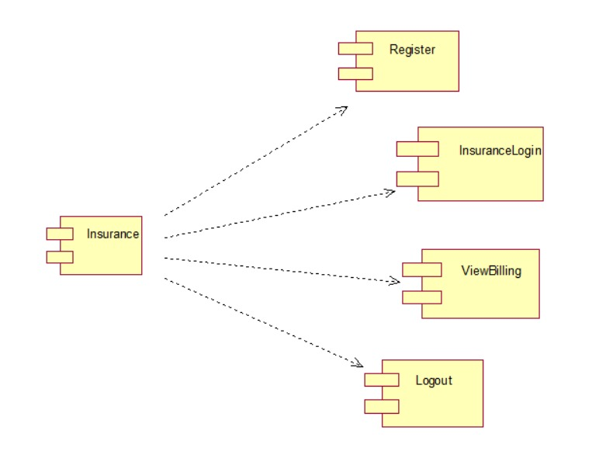
Deployment Diagram:
A deployment diagram in the Unified Modeling Language models the physical deployment of artifacts on nodes. To describe a web site, for example, a deployment diagram would show what hardware components ("nodes") exist (e.g., a web server, an application server, and a database server), what software components ("artifacts") run on each node (e.g., web application, database), and how the different pieces are connected (e.g. JDBC, REST, RMI).
The nodes appear as boxes, and the artifacts allocated to each node appear as rectangles within the boxes. Nodes may have sub nodes, which appear as nested boxes. A single node in a deployment diagram may conceptually represent multiple physical nodes, such as a cluster of database servers.
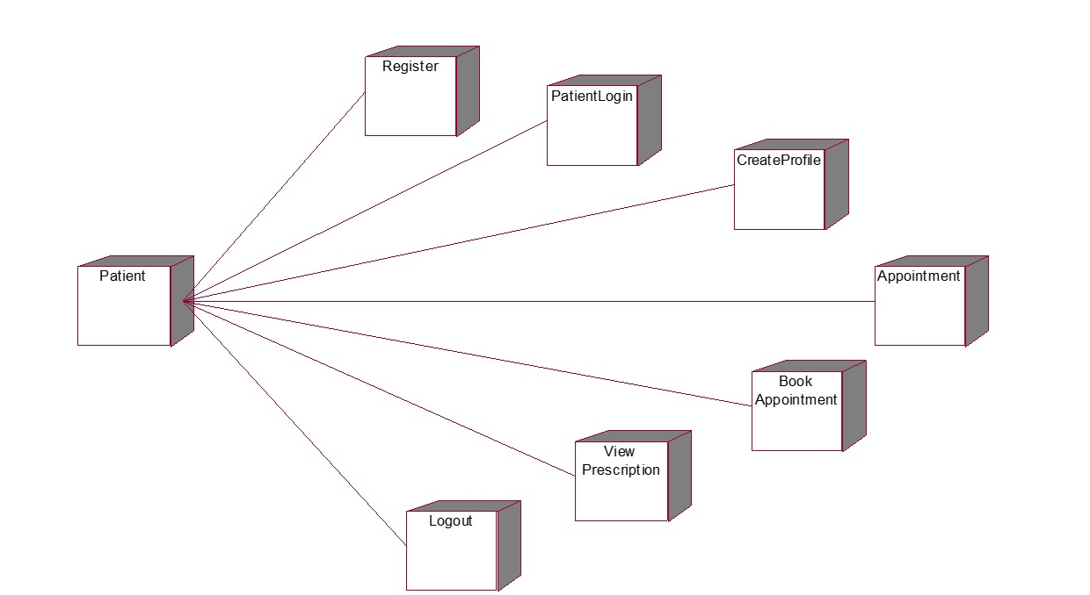
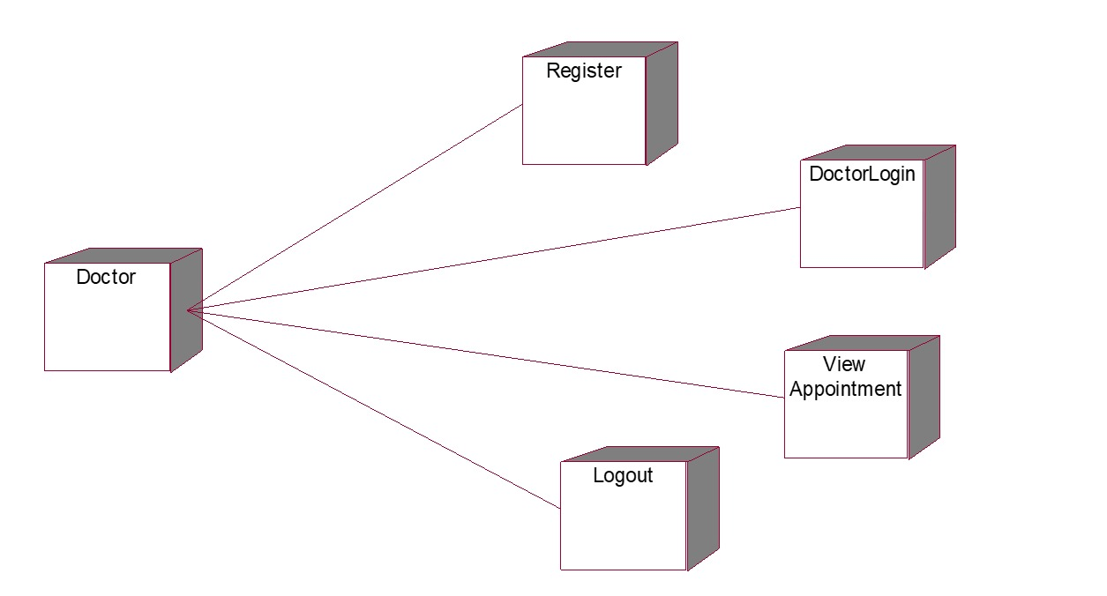
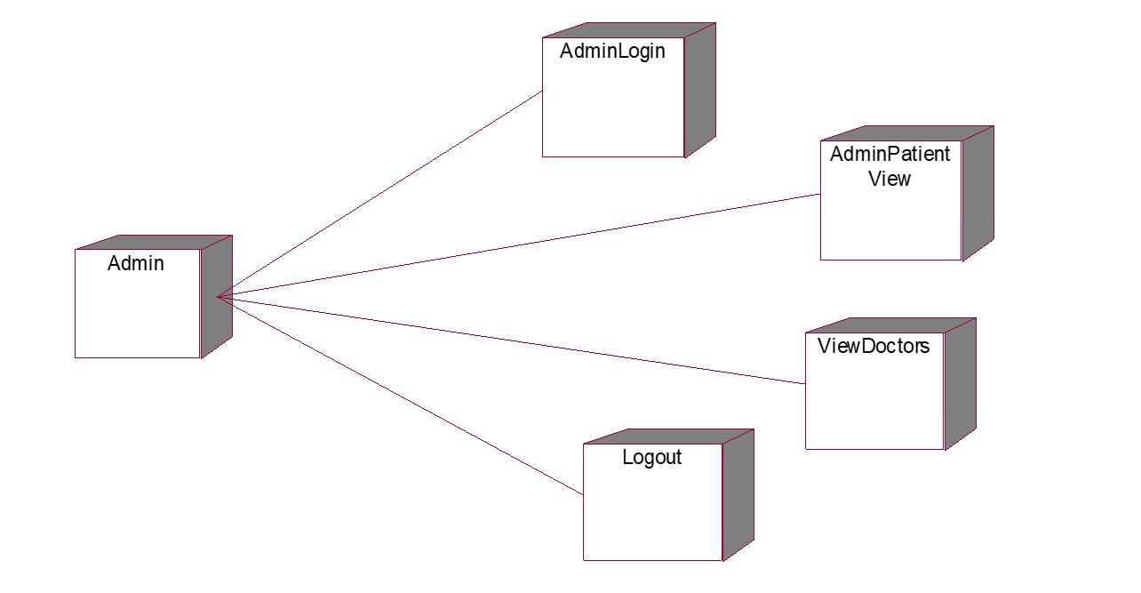
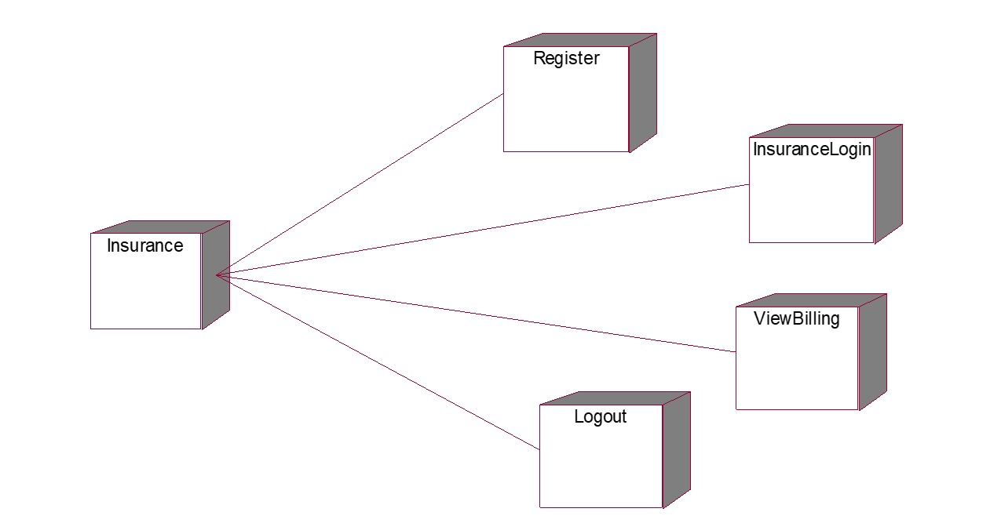
Activity Diagram:
Activity diagram is another important diagram in UML to describe dynamic aspects of the system. It is basically a flow chart to represent the flow form one activity to another activity. The activity can be described as an operation of the system. So the control flow is drawn from one operation to another. This flow can be sequential, branched or concurrent

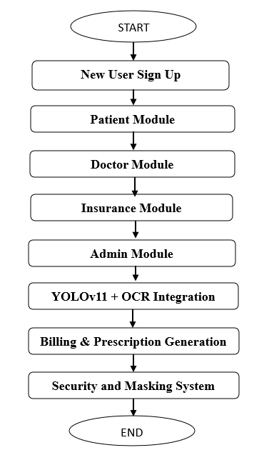
Data Flow Diagram:
Data flow diagrams illustrate how data is processed by a system in terms of inputs and outputs. Data flow diagrams can be used to provide a clear representation of any business function. The technique starts with an overall picture of the business and continues by analyzing each of the functional areas of interest. This analysis can be carried out in precisely the level of detail required. The technique exploits a method called top-down expansion to conduct the analysis in a targeted way.
As the name suggests, Data Flow Diagram (DFD) is an illustration that explicates the passage of information in a process. A DFD can be easily drawn using simple symbols. Additionally, complicated processes can be easily automated by creating DFDs using easy-to-use, free downloadable diagramming tools. A DFD is a model for constructing and analyzing information processes. DFD illustrates the flow of information in a process depending upon the inputs and outputs. A DFD can also be referred to as a Process Model. A DFD demonstrates business or technical process with the support of the outside data saved, plus the data flowing from the process to another and the end results

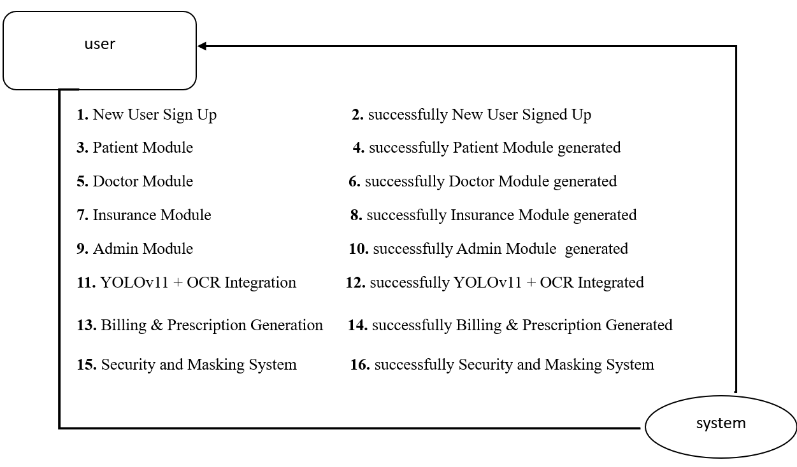

4. IMPLEMETATION
Python
Python is a general-purpose language. It has wide range of applications from Web development (like: Django and Bottle), scientific and mathematical computing (Orange, SymPy, NumPy) to desktop graphical user Interfaces (Pygame, Panda3D). The syntax of the language is clean and length of the code is relatively short. It's fun to work in Python because it allows you to think about the problem rather than focusing on the syntax.

History of Python:
Python is a fairly old language created by Guido Van Rossum. The design began in the late 1980s and was first released in February 1991.
Why Python was created?
In late 1980s, Guido Van Rossum was working on the Amoeba distributed operating system group. He wanted to use an interpreted language like ABC (ABC has simple easy-to-understand syntax) that could access the Amoeba system calls. So, he decided to create a language that was extensible. This led to design of a new language which was later named Python.
Why the name Python?
No. It wasn't named after a dangerous snake. Rossum was fan of a comedy series from late seventies. The name "Python" was adopted from the same series "Monty Python's Flying Circus".
Features of Python:
A simple language which is easier to learn
Python has a very simple and elegant syntax. It's much easier to read and write Python programs compared to other languages like: C++, Java, C#. Python makes programming fun and allows you to focus on the solution rather than syntax.
If you are a newbie, it's a great choice to start your journey with Python.
Free and open-source
You can freely use and distribute Python, even for commercial use. Not only can you use and distribute software’s written in it, you can even make changes to the Python's source code.
Python has a large community constantly improving it in each iteration.
Portability
You can move Python programs from one platform to another, and run it without any changes.
It runs seamlessly on almost all platforms including Windows, Mac OS X and Linux.
Extensible and Embeddable
Suppose an application requires high performance. You can easily combine pieces of C/C++ or other languages with Python code.
This will give your application high performance as well as scripting capabilities which other languages may not provide out of the box.
A high-level, interpreted language
Unlike C/C++, you don't have to worry about daunting tasks like memory management, garbage collection and so on.
Likewise, when you run Python code, it automatically converts your code to the language your computer understands. You don't need to worry about any lower-level operations.
Large standard libraries to solve common tasks
Python has a number of standard libraries which makes life of a programmer much easier since you don't have to write all the code yourself. For example: Need to connect MySQL database on a Web server? You can use MySQL dB library using import MySQL dB .
Standard libraries in Python are well tested and used by hundreds of people. So you can be sure that it won't break your application.
Object-oriented
Everything in Python is an object. Object oriented programming (OOP) helps you solve a complex problem intuitively.
With OOP, you are able to divide these complex problems into smaller sets by creating objects.
Applications of Python:
1. Simple Elegant Syntax
Programming in Python is fun. It's easier to understand and write Python code. Why? The syntax feels natural. Take this source code for an example:
a = 2
b = 3
sum = a + b
print(sum)
2. Not overly strict
You don't need to define the type of a variable in Python. Also, it's not necessary to add semicolon at the end of the statement.
Python enforces you to follow good practices (like proper indentation). These small things can make learning much easier for beginners.
3. Expressiveness of the language
Python allows you to write programs having greater functionality with fewer lines of code. Here's a link to the source code of Tic-tac-toe game with a graphical interface and a smart computer opponent in less than 500 lines of code. This is just an example. You will be amazed how much you can do with Python once you learn the basics.
4. Great Community and Support
Python has a large supporting community. There are numerous active forums online which can be handy if you are stuck.
Libraries:
PyMySQL:
PyMySQL is a lightweight, pure-Python MySQL client library used to connect Python applications to MySQL and MariaDB databases. It serves as an easy-to-use, open-source alternative to MySQL’s official connectors, making it convenient for database operations such as inserting, updating, querying, and managing data directly from Python. Since PyMySQL is written entirely in Python, it is highly portable, simple to install, and compatible with popular frameworks like Django, Flask, and SQLAlchemy.
PyMySQL enables seamless communication with MySQL servers using standard SQL commands. It provides essential features such as cursor-based query execution, transaction support, error handling, and secure authentication. It is widely used in web development, data analytics, backend APIs, and automation scripts due to its reliability and ease of integration.
• Here are some key features and functionalities of the PyMySQL library:
• Pure-Python MySQL Client (No External Dependencies)
• Easy Connection Between Python and MySQL
• Supports SQL Queries for CRUD Operations
• Cursor-Based Query Execution and Fetching
• Secure Authentication with Username & Password
• Supports Transactions and Commit/Rollback
• Compatible with MySQL and MariaDB
• Integrates with Web Frameworks Like Flask and Django
• Lightweight, Portable, and Easy to Install
• Useful for Web Apps, Automation, and Data Management
Django:
Django is a high-level, open-source Python web framework designed for building secure, scalable, and maintainable web applications rapidly. It follows the Model–View–Template (MVT) architectural pattern, enabling developers to separate business logic, data handling, and user interface efficiently. Django provides built-in features such as authentication, database ORM, URL routing, form handling, and security protections, making it one of the most powerful frameworks for backend development.
Django is widely used in real-world applications such as e-commerce platforms, content management systems (CMS), social networks, and enterprise-level web services. It promotes “batteries-included” development, meaning most essential components are available out-of-the-box, reducing development time. Django is known for its strong security features, including protection against SQL injection, CSRF, XSS, and clickjacking attacks. Due to its reliability, rapid development support, and scalability, Django is preferred in industries such as finance, e-commerce, education, entertainment, and healthcare.
• Here are some key features and functionalities of the Django framework:
• Follows the Model–View–Template (MVT) Architecture
• Built-in Object Relational Mapper (ORM) for Database Operations
• Automatic Admin Interface for Managing Data
• Robust Security Features (CSRF, XSS, SQL Injection Protection)
• URL Routing System for Clean and Organized URLs
• Integrated Authentication and Authorization System
• Supports Form Handling and Validation
• Highly Scalable with Caching and Middleware Support
• “Batteries-Included” Framework with Many Built-in Tools
• Easy Integration with Databases Like SQLite, MySQL, and PostgreSQL
• Excellent Documentation and Large Community Support
• Suitable for Large-Scale, High-Traffic Web Applications
OpenCV:
OpenCV (cv2) is a powerful, open-source computer vision and image-processing library widely used for building applications that involve real-time image analysis, video processing, object detection, facial recognition, and AI-driven vision tasks. The cv2 module is the official Python binding for OpenCV, enabling developers to work with advanced vision algorithms through simple and efficient Python functions. It supports various operations such as filtering, edge detection, color transformation, image segmentation, and deep learning–based recognition, making it one of the most essential libraries for AI, robotics, and computer vision systems.
OpenCV is optimized for performance, utilizing fast C/C++ backend code, GPU acceleration (CUDA), and highly efficient data structures. It is used in areas like autonomous vehicles, medical imaging, security surveillance, gesture recognition, AR/VR systems, and robotics navigation. With its wide range of tools and cross-platform support, OpenCV allows seamless integration with machine learning libraries like TensorFlow, Keras, and PyTorch for advanced CV tasks.
• Here are some key features and functionalities of the OpenCV (cv2) library:
• Supports Image Processing (Filtering, Thresholding, Transformations)
• Real-Time Video Processing Using Camera Streams
• Face, Object, and Motion Detection Using Pretrained Models
• Provides Deep Learning Support (DNN Module)
• Rich Set of Image Manipulation Functions (Resize, Crop, Rotate, Blur)
• Works with NumPy Arrays for Fast Data Processing
• Supports Feature Extraction (SIFT, SURF, ORB)
• Includes Tools for Contour Detection and Shape Analysis
• Enables Color Space Conversions (RGB, HSV, GRAYSCALE)
• Can Read, Write, and Display Images and Videos Easily
• Optimized for High Performance with C++ Backend and GPU Support
• Integrates with AI Frameworks Like TensorFlow and PyTorch
Matplotlib:
Matplotlib is a widely used, open-source Python library for data visualization and plotting. It provides a flexible and comprehensive framework for creating static, interactive, and animated visualizations in Python. Matplotlib enables developers, data analysts, and researchers to explore data, interpret trends, and communicate insights effectively through graphs, charts, and plots.
Matplotlib is highly compatible with other Python libraries like NumPy, pandas, and SciPy, making it an essential tool for scientific computing and machine learning pipelines. Its versatility allows users to create a wide variety of plots, including line plots, bar charts, histograms, scatter plots, pie charts, and 3D visualizations. Matplotlib is extensively used in fields such as data science, machine learning, finance, engineering, scientific research, and education.
• Here are some key features and functionalities of Matplotlib:
• High-Quality 2D and 3D Plotting Capabilities
• Extensive Types of Plots: Line, Scatter, Bar, Histogram, Pie, Area, etc.
• Customizable Styles, Colors, Fonts, and Layouts
• Supports Interactive Plots and Animations
• Compatible with NumPy and pandas Data Structures
• Integration with Jupyter Notebooks for Inline Visualization
• Figure and Axes Management for Complex Plots
• Export Plots to Multiple Formats (PNG, PDF, SVG, etc.)
• Enables Subplots, Grids, and Multi-Figure Layouts
• Widely Used in Data Analysis, Machine Learning, Scientific Research, and Reporting
Algorithm:
AES (Advanced Encryption Standard):
AES (Advanced Encryption Standard) is a widely used symmetric encryption algorithm designed to protect sensitive data by converting readable information (plaintext) into an unreadable format (ciphertext). It operates using a single secret key for both encryption and decryption, ensuring high-speed and secure communication. AES is considered one of the strongest and most reliable encryption standards, approved by NIST and used globally for securing data in government, banking, telecommunications, cloud platforms, and modern cybersecurity systems.
AES works on fixed-size data blocks (128-bit block size) and supports three key lengths: 128-bit, 192-bit, and 256-bit, with AES-256 offering the highest level of security. The algorithm performs multiple rounds of transformations such as SubBytes, ShiftRows, MixColumns, and AddRoundKey to ensure confidentiality, diffusion, and resistance against attacks. AES is used in technologies like SSL/TLS, VPNs, disk encryption (BitLocker), secure messaging, IoT security, and file protection, making it a fundamental component of modern cryptographic systems.
• Here are some key features and functionalities of the AES encryption algorithm:
• Symmetric-key Encryption (Same Key for Encryption & Decryption)
• Fixed 128-bit Block Size for Processing Data
• Supports 128, 192, and 256-bit Key Lengths
• Strong Security and Resistant to Known Cryptographic Attacks
• High Performance in Both Hardware and Software Implementations
• Used in TLS/SSL, VPNs, Wi-Fi Security (WPA2/WPA3)
• Performs Multiple Rounds of Substitution and Permutation
• Ideal for Encrypting Files, Messages, Databases, and Network Traffic
• Secure Standard Approved by NIST
• Lightweight and Efficient for IoT and Mobile Applications
• Commonly Implemented in Python Using Libraries Like PyCryptodome
You look only once (YOLO11):
YOLO11 is a state-of-the-art, real-time object detection model from the Ultralytics YOLO family, designed to deliver superior accuracy, faster inference, and improved generalization across diverse vision tasks. YOLO11 builds upon previous YOLO versions with enhanced backbone architecture, optimized transformer-based blocks, better feature fusion, and advanced training strategies. It is widely used for applications such as object detection, image segmentation, pose estimation, tracking, and classification.
YOLO11 provides efficient performance on both CPU and GPU, making it highly suitable for real-time systems such as autonomous vehicles, CCTV surveillance, drones, robotics, traffic monitoring, medical imaging, and smart city solutions. It supports deployment across platforms including Python, mobile devices, edge devices, cloud, and ONNX runtime. With its improved accuracy and lightweight model variants, YOLO11 balances speed and performance, making it one of the most reliable models for deep learning–based computer vision.
• Here are some key features and functionalities of the YOLO11 model:
• Real-Time Object Detection with High Accuracy
• Advanced Backbone Architecture for Better Feature Extraction
• Faster Inference on CPU, GPU, and Edge Devices
• Supports Multiple Vision Tasks (Detection, Segmentation, Pose Estimation)
• Improved Training with Augmentations Like Mosaic & Mixup
• Lightweight Variants (n, s) and High-Performance Variants (m, l, x)
• Ability to Track Objects Using Built-In Tracking Support
• Compatible with ONNX, TensorRT, CoreML, and TFLite
• User-Friendly Python API for Training and Inference
• Efficient for Small, Medium, and Large-Scale Datasets
• Highly Robust for Real-World Surveillance & Industrial Applications
Optical Character Recognition (OCR):
Optical Character Recognition (OCR) is a machine learning and computer vision technique used to automatically extract and convert text from images, scanned documents, handwritten notes, screenshots, and printed pages into machine-readable digital text. OCR algorithms analyze the visual structure of characters, detect text regions, and recognize each symbol using pattern-matching or deep-learning models. OCR is widely used in applications such as document digitization, automated form processing, license plate recognition, medical records, invoice scanning, and mobile text recognition.
Modern OCR systems combine multiple advanced techniques: image preprocessing, text detection, character segmentation, feature extraction, and text recognition using AI-based models such as CNNs, RNNs, and Transformers. Modern deep-learning OCR frameworks like Tesseract OCR, EasyOCR, PaddleOCR, and Google Vision API provide highly accurate recognition of printed as well as handwritten text across multiple languages and complex layouts.
• Here are some key features and functionalities of OCR algorithms:
• Converts Images or Scanned Documents into Editable Text
• Detects Text Regions Using Deep Learning (CRAFT, EAST Models)
• Recognizes Characters Using CNN–RNN–CTC Pipelines
• Supports Printed, Handwritten, and Multi-Language Text
• Preprocessing Tools (Denoising, Binarization, Thresholding)
• Accurate Layout Analysis for PDFs, Tables, and Forms
• Works on Noisy, Blurry, and Low-Resolution Images
• Supports Multiple Fonts, Styles, and Document Types
• Integrates Easily with Python Libraries Like Tesseract & EasyOCR
• Widely Used in Banking, Healthcare, Business Automation, and OCR Scanners
Sample code:
Views.py:
from django.shortcuts import render
from django.template import RequestContext
from django.contrib import messages
from django.http import HttpResponse
import os
from django.core.files.storage import FileSystemStorage
import pymysql
import pyaes, pbkdf2, binascii, os, secrets
import matplotlib.pyplot as plt
from matplotlib.offsetbox import TextArea, DrawingArea, OffsetImage, AnnotationBbox
import matplotlib.image as mpimg
import base64
import io
import cv2

global uname, resume_name

def getKey(): #generating AES key based on Diffie common secret shared key
password = "s3cr3t*c0d3"
passwordSalt = str("0986543")#get AES key using diffie
key = pbkdf2.PBKDF2(password, passwordSalt).read(32)
return key

def encrypt(plaintext): #AES data encryption
aes = pyaes.AESModeOfOperationCTR(getKey(), pyaes.Counter(31129547035000047302952433967654195398124239844566322884172163637846056248223))
ciphertext = aes.encrypt(plaintext)
return ciphertext

def decrypt(enc): #AES data decryption
aes = pyaes.AESModeOfOperationCTR(getKey(), pyaes.Counter(31129547035000047302952433967654195398124239844566322884172163637846056248223))
decrypted = aes.decrypt(enc)
return decrypted

def UserLogin(request):
if request.method == 'GET':
return render(request, 'UserLogin.html', {})

def index(request):
if request.method == 'GET':
return render(request, 'index.html', {})

def Signup(request):
if request.method == 'GET':
return render(request, 'Signup.html', {})

def UserLoginAction(request):
if request.method == 'POST':
global uname
username = request.POST.get('t1', False)
password = request.POST.get('t2', False)
index = 0
con = pymysql.connect(host='127.0.0.1',port = 3306,user = 'root', password = 'root', database = 'resumebuilder',charset='utf8')
with con:
cur = con.cursor()
cur.execute("select username,password FROM signup")
rows = cur.fetchall()
for row in rows:
if row[0] == username and password == row[1]:
uname = username
index = 1
break
if index == 1:
context= {'data':'welcome '+uname}
return render(request, 'UserScreen.html', context)
else:
context= {'data':'login failed'}
return render(request, 'UserLogin.html', context)

def SignupAction(request):
if request.method == 'POST':
username = request.POST.get('t1', False)
password = request.POST.get('t2', False)
fullname = request.POST.get('t3', False)
contact = request.POST.get('t4', False)
gender = request.POST.get('t5', False)
email = request.POST.get('t6', False)
address = request.POST.get('t7', False)
edu1 = request.POST.get('t8', False)
edu2 = request.POST.get('t9', False)
edu3 = request.POST.get('t10', False)
edu4 = request.POST.get('t11', False)
output = "none"
con = pymysql.connect(host='127.0.0.1',port = 3306,user = 'root', password = 'root', database = 'resumebuilder',charset='utf8')
with con:
cur = con.cursor()
cur.execute("select username FROM signup")
rows = cur.fetchall()
for row in rows:
if row[0] == username:
output = username+" Username already exists"
break
if output == 'none':
db_connection = pymysql.connect(host='127.0.0.1',port = 3306,user = 'root', password = 'root', database = 'resumebuilder',charset='utf8')
db_cursor = db_connection.cursor()
student_sql_query = "INSERT INTO signup VALUES('"+username+"','"+password+"','"+fullname+"','"+contact+"','"+gender+"','"+email+"','"+address+"','"+edu1+"','"+edu2+"','"+edu3+"','"+edu4+"')"
db_cursor.execute(student_sql_query)
db_connection.commit()
print(db_cursor.rowcount, "Record Inserted")
if db_cursor.rowcount == 1:
output = 'Signup Process Completed'
context= {'data':output}
return render(request, 'Signup.html', context)

def UpdateProfile(request):
if request.method == 'GET':
global uname
password=""
fullname=""
contact=""
gender=""
email=""
address=""
edu1=""
edu2=""
edu3=""
edu4=""
con = pymysql.connect(host='127.0.0.1',port = 3306,user = 'root', password = 'root', database = 'resumebuilder',charset='utf8')
with con:
cur = con.cursor()
cur.execute("select * FROM signup where username='"+uname+"'")
rows = cur.fetchall()
for row in rows:
uname = row[0]
password = row[1]
fullname = row[2]
contact = row[3]
gender = row[4]
email = row[5]
address = row[6]
edu1 = row[7]
edu2 = row[8]
edu3 = row[9]
edu4 = row[10]
output = '<tr><td><font size="3" color="black">Username</b></td>'
output += '<td><input type="text" name="t1" style="font-family: Comic Sans MS" size="30" value="'+uname+'" readonly/></td></tr>'
output += '<tr><td><font size="3" color="black">Password</b></td><td><input name="t2" type="password" size="30" value="'+password+'"></td></tr>'
output += '<tr><td><font size="3" color="black">Full&nbsp;Name</b></td><td><input type="text" name="t3" style="font-family: Comic Sans MS" size="50" value="'+fullname+'"></td></tr>'
output += '<tr><td><font size="3" color="black">Contact&nbsp;No</b></td><td><input name="t4" type="Text" size="15" value="'+contact+'"></td></td></tr>'
output += '<tr><td><font size="3" color="black">Gender</b></td><td><input name="t5" type="Text" size="15" value="'+gender+'" readonly></td></td></tr>'
output += '<tr><td><font size="3" color="black">Email&nbsp;ID</b></td><td><input type="text" name="t6" style="font-family: Comic Sans MS" size="50" value="'+email+'"/></td></tr>'
output += '<tr><td><font size="3" color="black">Address</b></td><td><input name="t7" type="Text" size="70" value="'+address+'"></td></td></tr>'
output += '<tr><td><font size="3" color="black">Educational&nbsp;Details1</b></td><td><input name="t8" type="Text" size="70" value="'+edu1+'"></td></td></tr>'
output += '<tr><td><font size="3" color="black">Educational&nbsp;Details2</b></td><td><input name="t9" type="Text" size="70" value="'+edu2+'"></td></td></tr>'
output += '<tr><td><font size="3" color="black">Educational&nbsp;Details3</b></td><td><input name="t10" type="Text" size="70" value="'+edu3+'"></td></td></tr>'
output += '<tr><td><font size="3" color="black">Educational&nbsp;Details4</b></td><td><input name="t11" type="Text" size="70" value="'+edu4+'"></td></td></tr>'
output += '<tr><td></td><td><input type="submit" value="Submit"></td>'
context= {'data1':output}
return render(request, 'UpdateProfile.html', context)

def sharedResume(uname, sharing_users, resume_name):
for i in range(len(sharing_users)):
db_connection = pymysql.connect(host='127.0.0.1',port = 3306,user = 'root', password = 'root', database = 'resumebuilder',charset='utf8')
db_cursor = db_connection.cursor()
student_sql_query = "INSERT INTO share VALUES('"+uname+"','"+sharing_users[i]+"','"+resume_name+"')"
db_cursor.execute(student_sql_query)
db_connection.commit()

def UpdateProfileAction(request):
if request.method == 'POST':
username = request.POST.get('t1', False)
password = request.POST.get('t2', False)
fullname = request.POST.get('t3', False)
contact = request.POST.get('t4', False)
gender = request.POST.get('t5', False)
email = request.POST.get('t6', False)
address = request.POST.get('t7', False)
edu1 = request.POST.get('t8', False)
edu2 = request.POST.get('t9', False)
edu3 = request.POST.get('t10', False)
edu4 = request.POST.get('t11', False)
uname = username
db_connection = pymysql.connect(host='127.0.0.1',port = 3306,user = 'root', password = 'root', database = 'resumebuilder',charset='utf8')
db_cursor = db_connection.cursor()
student_sql_query = "delete from signup where username='"+username+"'"
db_cursor.execute(student_sql_query)
db_connection.commit()
db_connection = pymysql.connect(host='127.0.0.1',port = 3306,user = 'root', password = 'root', database = 'resumebuilder',charset='utf8')
db_cursor = db_connection.cursor()
student_sql_query = "INSERT INTO signup VALUES('"+username+"','"+password+"','"+fullname+"','"+contact+"','"+gender+"','"+email+"','"+address+"','"+edu1+"','"+edu2+"','"+edu3+"','"+edu4+"')"
db_cursor.execute(student_sql_query)
db_connection.commit()
print(db_cursor.rowcount, "Record Inserted")
if db_cursor.rowcount == 1:
output = 'Profile updated successfully'
context= {'data':output}
return render(request, 'UserScreen.html', context)

def GenerateResume(request):
if request.method == 'GET':
global uname
output = '<tr><td><font size="" color="black">Choose&nbsp;Shared&nbsp;Users</b></td><td><select name="t9" multiple>'
con = pymysql.connect(host='127.0.0.1',port = 3306,user = 'root', password = 'root', database = 'resumebuilder',charset='utf8')
with con:
cur = con.cursor()
cur.execute("select username FROM signup")
rows = cur.fetchall()
for row in rows:
if row[0] != uname:
output += '<option value="'+row[0]+'">'+row[0]+'</option>'
output += "</select></td></tr>"
context= {'data1':output}
return render(request, 'GenerateResume.html', context)

def getDetails(uname):
password=""
fullname=""
contact=""
gender=""
email=""
address=""
edu1=""
edu2=""
edu3=""
edu4=""
con = pymysql.connect(host='127.0.0.1',port = 3306,user = 'root', password = 'root', database = 'resumebuilder',charset='utf8')
with con:
cur = con.cursor()
cur.execute("select * FROM signup where username='"+uname+"'")
rows = cur.fetchall()
for row in rows:
uname = row[0]
password = row[1]
fullname = row[2]
contact = row[3]
gender = row[4]
email = row[5]
address = row[6]
edu1 = row[7]
edu2 = row[8]
edu3 = row[9]
edu4 = row[10]
return uname, password, fullname, contact, gender, email, address, edu1, edu2, edu3, edu4

def GenerateResumeAction(request):
if request.method == 'POST':
global uname, resume_name
uname, password, fullname, contact, gender, email, address, edu1, edu2, edu3, edu4 = getDetails(uname)
font = request.POST.get('t1', False)
title = request.POST.get('t2', False)
project1 = request.POST.get('t3', False)
project2 = request.POST.get('t4', False)
project3 = request.POST.get('t5', False)
skills = request.POST.get('t6', False)
activities = request.POST.get('t7', False)
image = request.FILES['t8'].read()
sharing_users = request.POST.getlist('t9')
if os.path.exists("ResumeApp/static/test.png"):
os.remove("ResumeApp/static/test.jpg")
with open("ResumeApp/static/test.jpg", "wb") as file:
file.write(image)
file.close()

plt.rcParams['font.family'] = font
plt.rcParams['font.sans-serif'] = 'STIXGeneral'
fig, ax = plt.subplots(figsize=(8.5, 11))
ax.axvline(x=.5, ymin=0, ymax=1, color='#007ACC', alpha=0.0, linewidth=50)
plt.axvline(x=.99, color='#000000', alpha=0.5, linewidth=300)
plt.axhline(y=.88, xmin=0, xmax=1, color='#ffffff', linewidth=3)
ax.set_facecolor('white')
plt.axis('off')
address = address.replace(",", "\n")
skills = skills.replace(",", "\n")
edu1 = edu1.replace(",", "\n")
edu2 = edu2.replace(",", "\n")
edu3 = edu3.replace(",", "\n")
edu4 = edu4.replace(",", "\n")
project1 = project1.replace(",", "\n")
project2 = project2.replace(",", "\n")
project3 = project3.replace(",", "\n")
activities = activities.replace(",", "\n")

plt.annotate('Resume', (.02,.98), weight='regular', fontsize=8, alpha=.6)
plt.annotate(fullname, (.02,.94), weight='bold', fontsize=12)
plt.annotate(title, (.02,.91), weight='regular', fontsize=10)
plt.annotate(address, (.7,.906), weight='regular', fontsize=8, color='#ffffff')

plt.annotate('Education Details1', (.02,.86), weight='bold', fontsize=10, color='#58C1B2')
plt.annotate('Schooling', (.02,.832), weight='bold', fontsize=8)
plt.annotate(edu1, (.04,.78), weight='regular', fontsize=6)
plt.annotate('Education Details2', (.02,.745), weight='bold', fontsize=10, color='#58C1B2')
plt.annotate('Intermediate', (.04,.71), weight='bold', fontsize=8)
plt.annotate(edu2, (.02,.672), weight='regular', fontsize=6)
plt.annotate('Education Details3', (.04,.638), weight='bold', fontsize=10, color='#58C1B2')
plt.annotate('Graduation', (.02,.6), weight='bold', fontsize=8)
plt.annotate(edu3, (.02,.54), weight='regular', fontsize=6)
plt.annotate('Education Details4', (.02,.508), weight='bold', fontsize=10, color='#58C1B2')
plt.annotate('Masters', (.02,.493), weight='bold', fontsize=8)
plt.annotate(edu4, (.04,.445), weight='regular', fontsize=6)

plt.annotate('Recent Project Development', (.02,.4), weight='bold', fontsize=10)
plt.annotate('Project1', (.02,.385), weight='regular', fontsize=10)
plt.annotate(project1, (.04,.337), weight='regular', fontsize=6)
plt.annotate('Project2', (.02,.295), weight='regular', fontsize=10)
#plt.annotate('Description', (.02,.28), weight='regular', fontsize=8, alpha=.6)
plt.annotate(project2, (.04,.247), weight='regular', fontsize=6)
plt.annotate('Project3', (.02,.185), weight='regular', fontsize=10)
#plt.annotate('Description', (.02,.155), weight='bold', fontsize=10)
plt.annotate(project3, (.02,.14), weight='regular', fontsize=6)
plt.annotate('Skills', (.7,.8), weight='bold', fontsize=10, color='#ffffff')
plt.annotate(skills, (.7,.56), weight='regular', fontsize=10, color='#ffffff')
plt.annotate('Extra Activity', (.7,.43), weight='bold', fontsize=10, color='#ffffff')
plt.annotate(activities, (.7,.345), weight='regular', fontsize=10, color='#ffffff')
count = 0
for root, dirs, directory in os.walk('ResumeApp/static/files'):
for j in range(len(directory)):
count = count + 1
count += 1
arr_code = mpimg.imread('ResumeApp/static/test.jpg')
imagebox = OffsetImage(arr_code, zoom=0.5)
ab = AnnotationBbox(imagebox, (0.84, 0.12))
ax.add_artist(ab)
resume_name = 'ResumeApp/static/files/'+uname+"_"+str(count)+".png"
plt.savefig('ResumeApp/static/files/'+uname+"_"+str(count)+".png", dpi=300, bbox_inches='tight')
img = cv2.imread('ResumeApp/static/files/'+uname+"_"+str(count)+".png")
img = cv2.resize(img, (1222, 2601))
os.remove('ResumeApp/static/files/'+uname+"_"+str(count)+".png")
cv2.imwrite('ResumeApp/static/files/'+uname+"_"+str(count)+".png", img)
with open('ResumeApp/static/files/'+uname+"_"+str(count)+".png", "rb") as file:
data = file.read()
file.close()
enc = encrypt(data)
os.remove('ResumeApp/static/files/'+uname+"_"+str(count)+".png")
with open('ResumeApp/static/files/'+uname+"_"+str(count)+".png", "wb") as file:
file.write(enc)
file.close()
buf = io.BytesIO()
plt.savefig(buf, format='png', bbox_inches='tight')
plt.close()
img_b64 = base64.b64encode(buf.getvalue()).decode()
sharedResume(uname, sharing_users, uname+"_"+str(count)+".png")
context= {'data':'Resume Preview', 'img': img_b64}
return render(request, 'UserScreen.html', context)

def Download(request):
if request.method == 'GET':
global username
output = "Error in saving auth image"
fname = request.GET.get('fname', False)
with open ("ResumeApp/static/files/"+fname, "rb") as file:
data = file.read()
file.close()
data = decrypt(data)
response = HttpResponse(data, content_type='text/plain')
response['Content-Disposition'] = 'attachment; filename=%s' % fname
return response

def ViewPrevious(request):
if request.method == 'GET':
global uname
font = '<font size="" color="black">'
output = '<table border="1" align="center" width="100%"><tr><th>'+font+'Resume Name</th><td>'+font+'Resume Image</th><td>'+font+'Download Resume</th></tr>'
for root, dirs, directory in os.walk('ResumeApp/static/files'):
for j in range(len(directory)):
if uname in directory[j]:
with open ("ResumeApp/static/files/"+directory[j], "rb") as file:
data = file.read()
file.close()
data = decrypt(data)
if os.path.exists("ResumeApp/static/test.jpg"):
os.remove("ResumeApp/static/test.jpg")
with open ("ResumeApp/static/test.jpg", "wb") as file:
file.write(data)
file.close()
output+="<tr><td>"+font+directory[j]+"</td>"
output += '<td><img src="static/test.jpg" height="200" width="200"/>'
output+='<td><a href=\'Download?fname='+directory[j]+'\'><font size=3 color=black>Click Here to Download</font></a></td></tr>'
context= {'data':output}
return render(request, "UserScreen.html", context)
def ViewShared(request):
if request.method == 'GET':
global uname
username = request.POST.get('t1', False)
password = request.POST.get('t2', False)
font = '<font size="" color="black">'
output = '<table border="1" align="center" width="100%"><tr><th>'+font+'Resume Owner Name</th><th>'+font+'Sharing Username</th>'
output += '<th>'+font+'Resume Image</th><th>'+font+'Download Resume</th></tr>'
con = pymysql.connect(host='127.0.0.1',port = 3306,user = 'root', password = 'root', database = 'resumebuilder',charset='utf8')
with con:
cur = con.cursor()
cur.execute("select * FROM share where share_users='"+uname+"'")
rows = cur.fetchall()
for row in rows:
output+="<tr><td>"+font+row[0]+"</td>"
output+="<td>"+font+row[1]+"</td>"
filename = row[2]
with open ("ResumeApp/static/files/"+filename, "rb") as file:
data = file.read()
file.close()
data = decrypt(data)
if os.path.exists("ResumeApp/static/test.jpg"):
os.remove("ResumeApp/static/test.jpg")
with open ("ResumeApp/static/test.jpg", "wb") as file:
file.write(data)
file.close()
output += '<td><img src="static/test.jpg" height="200" width="200"/>'
output+='<td><a href=\'Download?fname='+filename+'\'><font size=3 color=black>Click Here to Download</font></a></td></tr>'
context= {'data':output}
return render(request, "UserScreen.html", context)
6. TESTING
Implementation and Testing:
Implementation is one of the most important tasks in project is the phase in which one has to be cautions because all the efforts undertaken during the project will be very interactive. Implementation is the most crucial stage in achieving successful system and giving the users confidence that the new system is workable and effective. Each program is tested individually at the time of development using the sample data and has verified that these programs link together in the way specified in the program specification. The computer system and its environment are tested to the satisfaction of the user.

Implementation

The implementation phase is less creative than system design. It is primarily concerned with user training, and file conversion. The system may be requiring extensive user training. The initial parameters of the system should be modifies as a result of a programming. A simple operating procedure is provided so that the user can understand the different functions clearly and quickly. The different reports can be obtained either on the inkjet or dot matrix printer, which is available at the disposal of the user. The proposed system is very easy to implement. In general implementation is used to mean the process of converting a new or revised system design into an operational one.

Testing
Testing is the process where the test data is prepared and is used for testing the modules individually and later the validation given for the fields. Then the system testing takes place which makes sure that all components of the system property functions as a unit. The test data should be chosen such that it passed through all possible condition. Actually testing is the state of implementation which aimed at ensuring that the system works accurately and efficiently before the actual operation commence. The following is the description of the testing strategies, which were carried out during the testing period.

System Testing
Testing has become an integral part of any system or project especially in the field of information technology. The importance of testing is a method of justifying, if one is ready to move further, be it to be check if one is capable to with stand the rigors of a particular situation cannot be underplayed and that is why testing before development is so critical. When the software is developed before it is given to user to use the software must be tested whether it is solving the purpose for which it is developed. This testing involves various types through which one can ensure the software is reliable. The program was tested logically and pattern of execution of the program for a set of data are repeated. Thus the code was exhaustively checked for all possible correct data and the outcomes were also checked.
Module Testing
To locate errors, each module is tested individually. This enables us to detect error and correct it without affecting any other modules. Whenever the program is not satisfying the required function, it must be corrected to get the required result. Thus all the modules are individually tested from bottom up starting with the smallest and lowest modules and proceeding to the next level. Each module in the system is tested separately. For example the job classification module is tested separately. This module is tested with different job and its approximate execution time and the result of the test is compared with the results that are prepared manually. The comparison shows that the results proposed system works efficiently than the existing system. Each module in the system is tested separately. In this system the resource classification and job scheduling modules are tested separately and their corresponding results are obtained which reduces the process waiting time.
Integration Testing
After the module testing, the integration testing is applied. When linking the modules there may be chance for errors to occur, these errors are corrected by using this testing. In this system all modules are connected and tested. The testing results are very correct. Thus the mapping of jobs with resources is done correctly by the system.
Acceptance Testing
When that user fined no major problems with its accuracy, the system passers through a final acceptance test. This test confirms that the system needs the original goals, objectives and requirements established during analysis without actual execution which elimination wastage of time and money acceptance tests on the shoulders of users and management, it is finally acceptable and ready for the operation
Test Case Id | Test Case Name | Testcase Desc. | Test Steps |  |  | Test Case Status | Test Priority
Test Case Id | Test Case Name | Testcase Desc. | Step | Expected | Actual | Test Case Status | Test Priority
O1 | New User Sign Up | Test whether the user signed or not | If user is not signed we cannot do anything | we cannot do any further operations | we can do further operations | High | High
02 | Patient Module | Test whether the patient module is generated or not | If patient module is not generated | we cannot do any further operations | we can do further operations | High | High
03 | Doctor Module | Test whether the doctor module is generated or not | If doctor module is not generated | We cannot run further  operation | We can Run the Operation | High | High
04 | Insurance Module | Test whether the insurance module is generated or not | If insurance module is not generated | We cannot run  operation | We can Run the Operation | High | High
05 | Admin Module | Test whether the admin module is generated or not | If admin module is not generated | We cannot run another  operation | We can Run the Operation | High | High
06 | YOLOv11 + OCR Integration | Test whether the YOLO11 and OCR is integrated or not | If YOLO11 and OCR is not integrated | We cannot run another  operation | We can Run the Operation | High | High
07 | Billing & Prescription Generation | Test whether the billing & prescription is generated or not | If billing & prescription is not generated | We cannot run another  operation | We can Run the Operation | High | High
08 | Security and Masking System | Test whether security and masking system working or not | If security and masking system is not working | We cannot run another  operation | We can Run the Operation | High | High

SCREEN SHOTS:
To run project install MYSQL database and then copy content from ‘db.txt’ file and paste in MYSQL console to create database
Install python 3.10 and then install all packages given in requirements.txt file ad then double click on ‘run. Bat’ file to start python web server and get below page
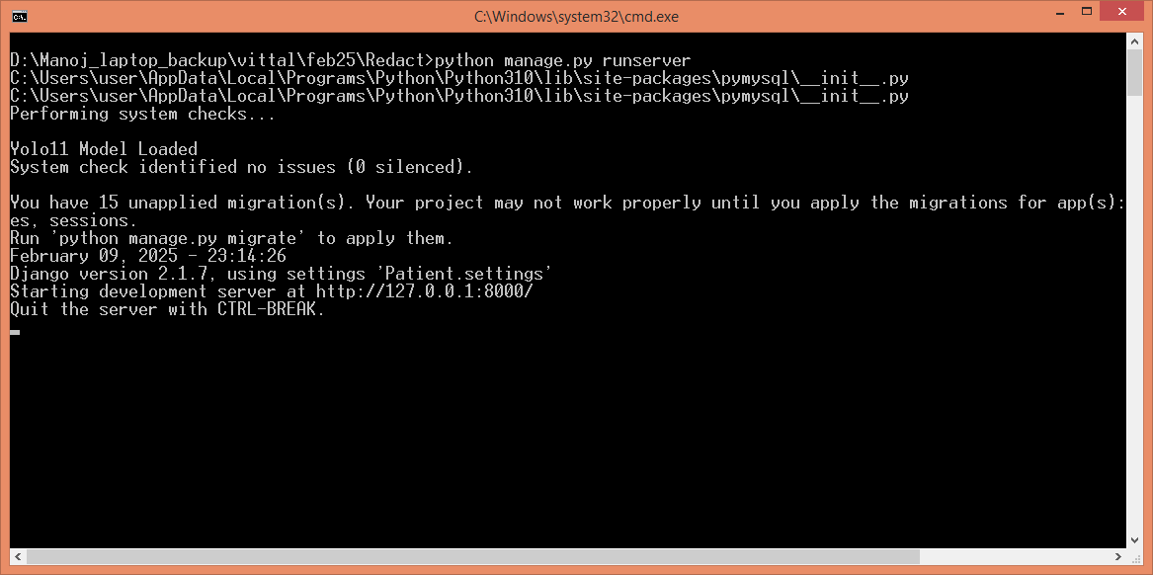
In above screen python server started and now open browser and enter URL as http://127.0.0.1:8000/index.html and then press enter key to get below page
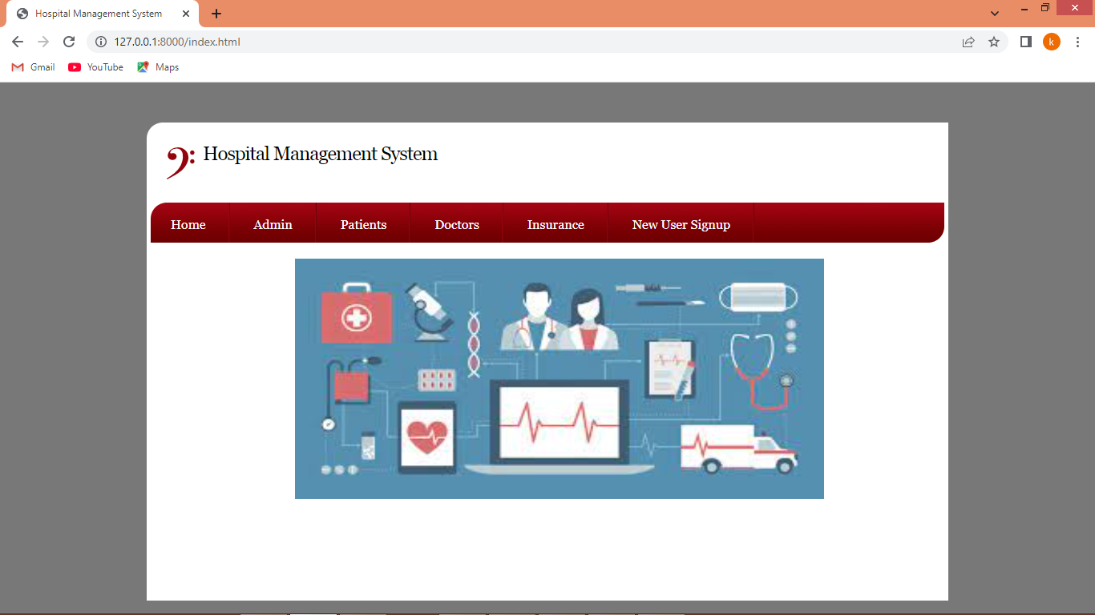
In above screen click on ‘New User Sign up’ link to get below page
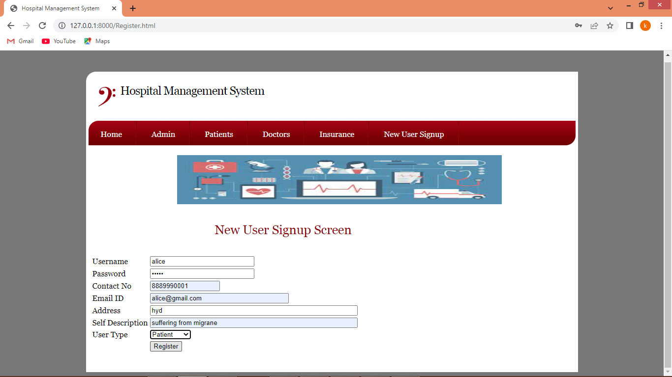
In above screen patient is entering sign up details and then press button to get below page
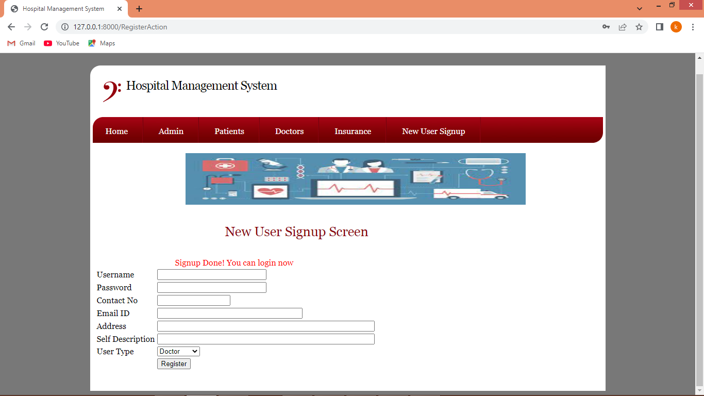
In above screen sign up process completed and similarly you can add doctors and insurance users like below page
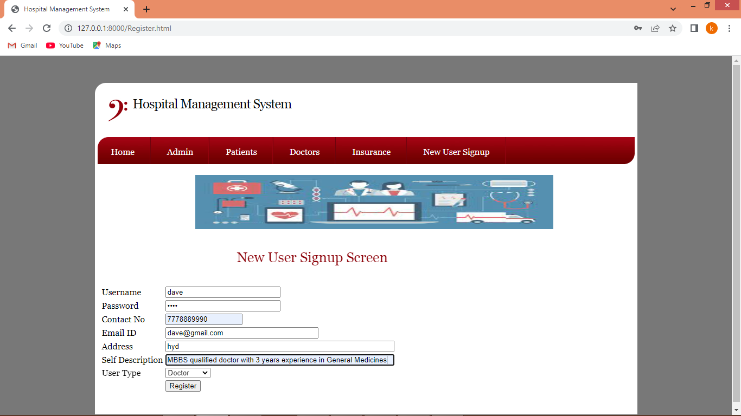
In above screen adding doctor details and then press button to complete doctor signup
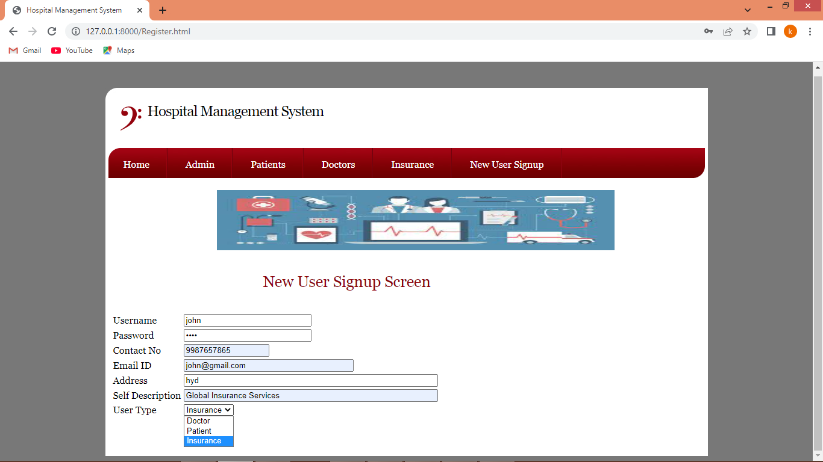
In above screen adding Insurance user and then press button to complete sign up task. Now click on ‘Patient Login’ link to get below page
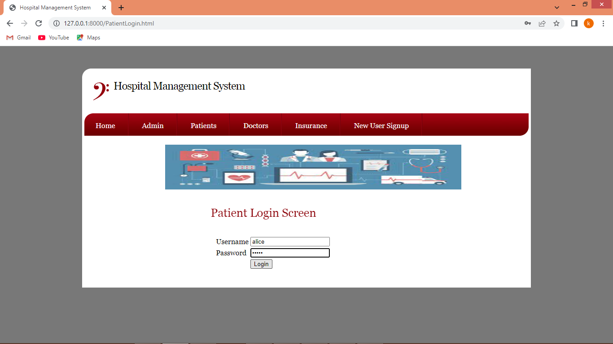
In above screen patient is login and after login will get below page
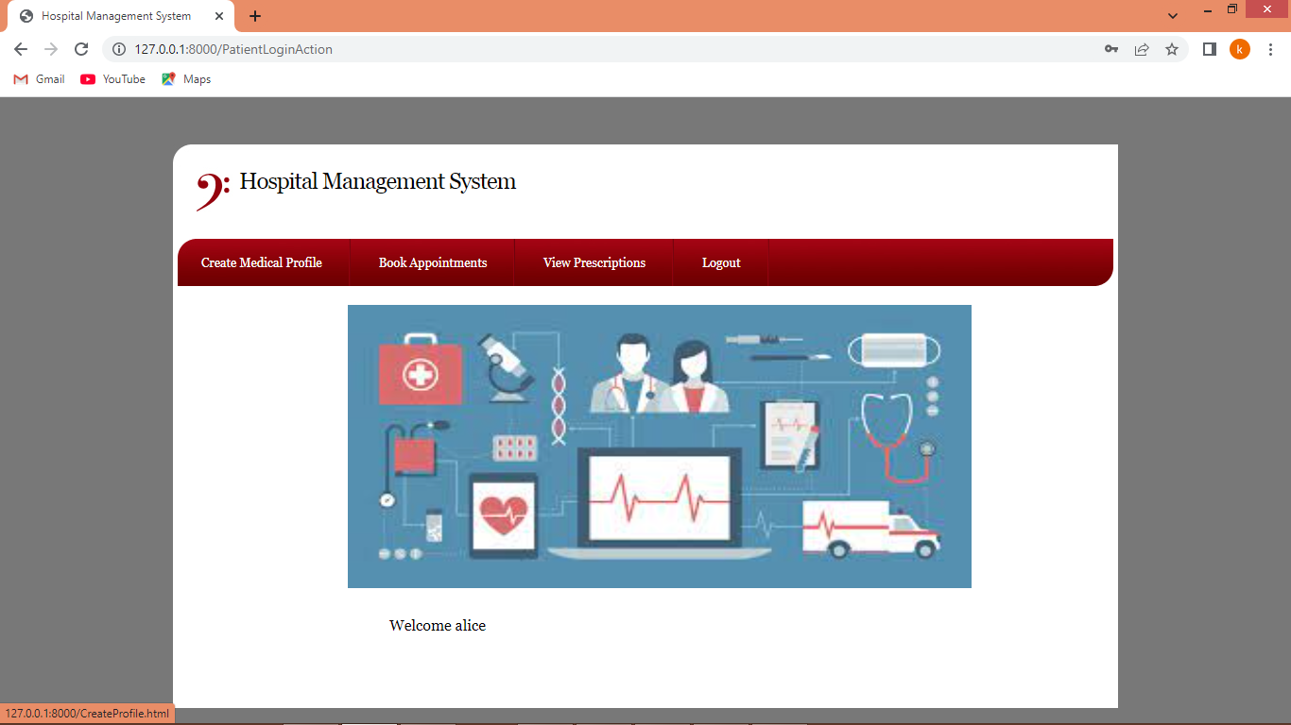
In above screen click on ‘Create Medical Profile’ link to get below page
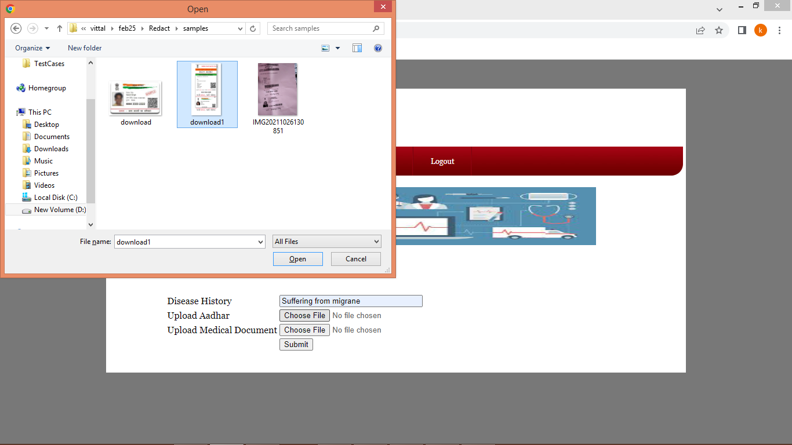
In above screen uploading sample Aadhar card and now click on ‘second button’ to upload medical history report like below page
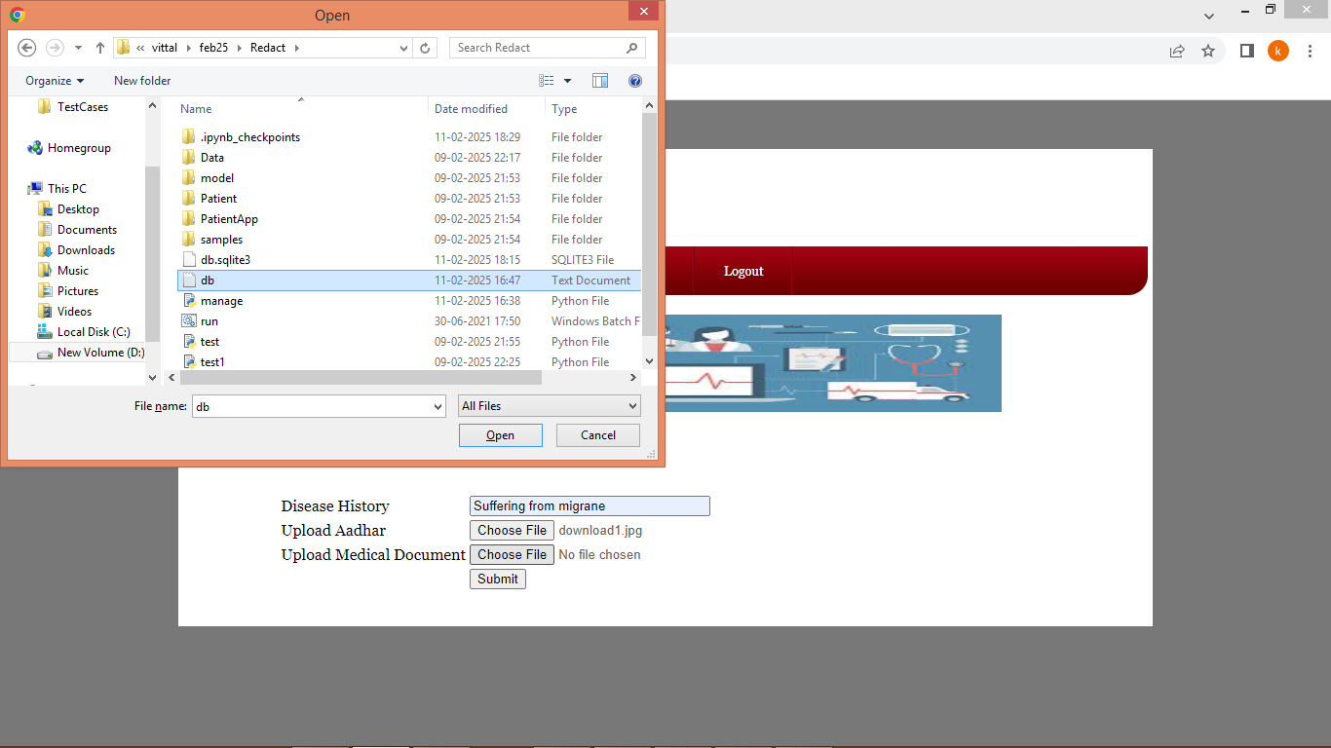
In above screen uploading medical history report and then click on ‘Open and submit’ button to load all documents and then application will extract Aadhar card number and then display below confirmation screen
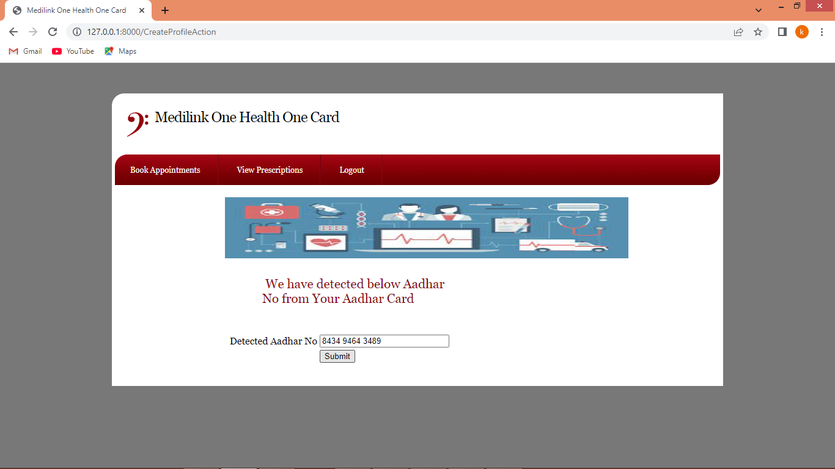
In above screen we are displaying confirmation screen to patient that extracted Aadhar correct then they can submit button or can alter to correct number and then press submit button to create profile and get below page
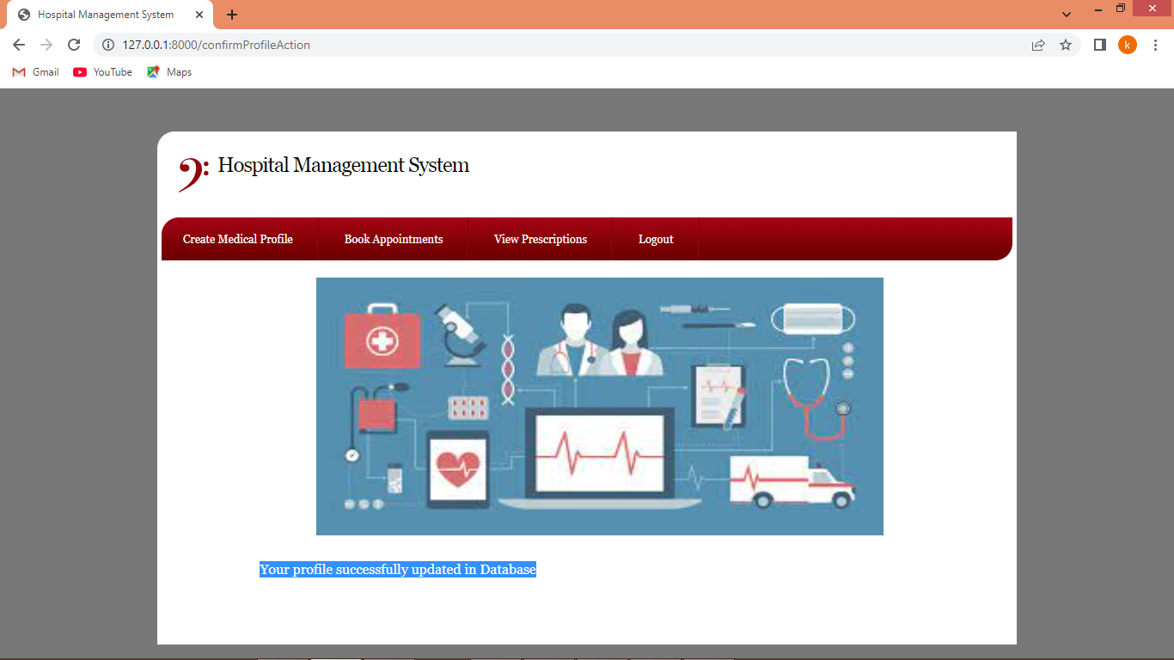
In above screen profile successfully created and now clicks on ‘Book Appointments’ link to create appointment like below page
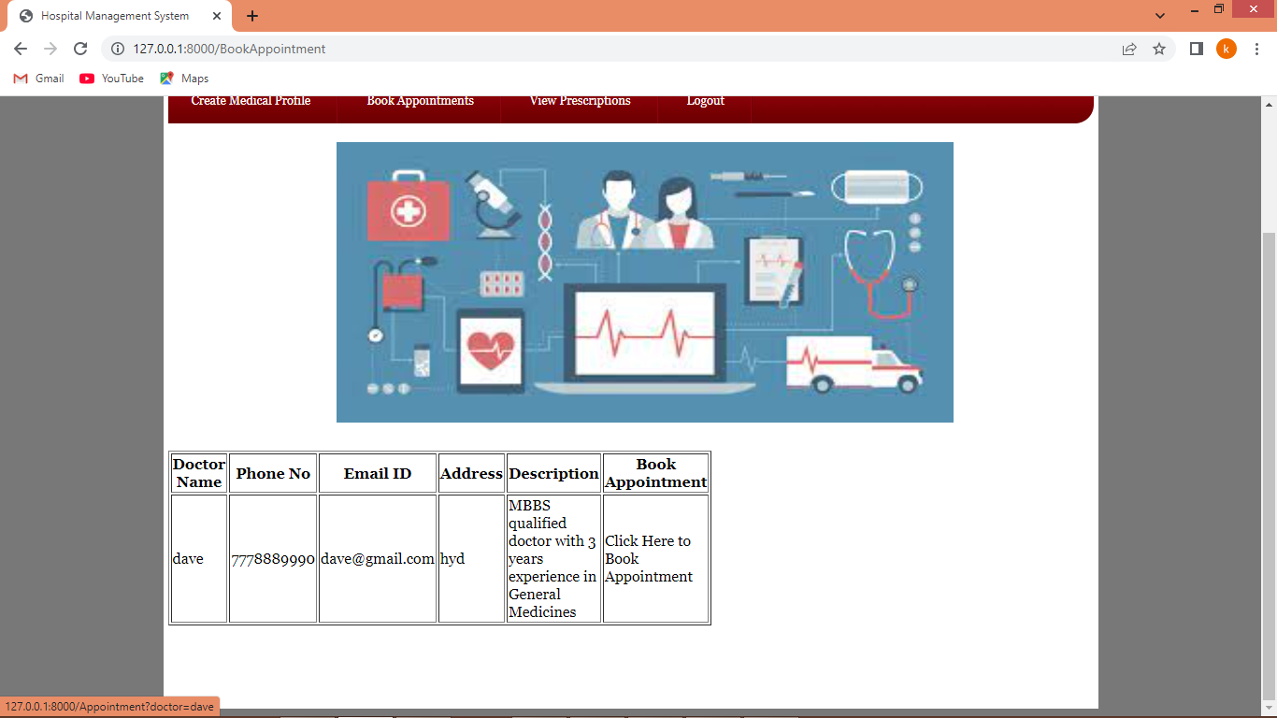
In above screen patient can view list of doctors and can click on ‘Click Here’ link to book appointment with desired doctor and get below page
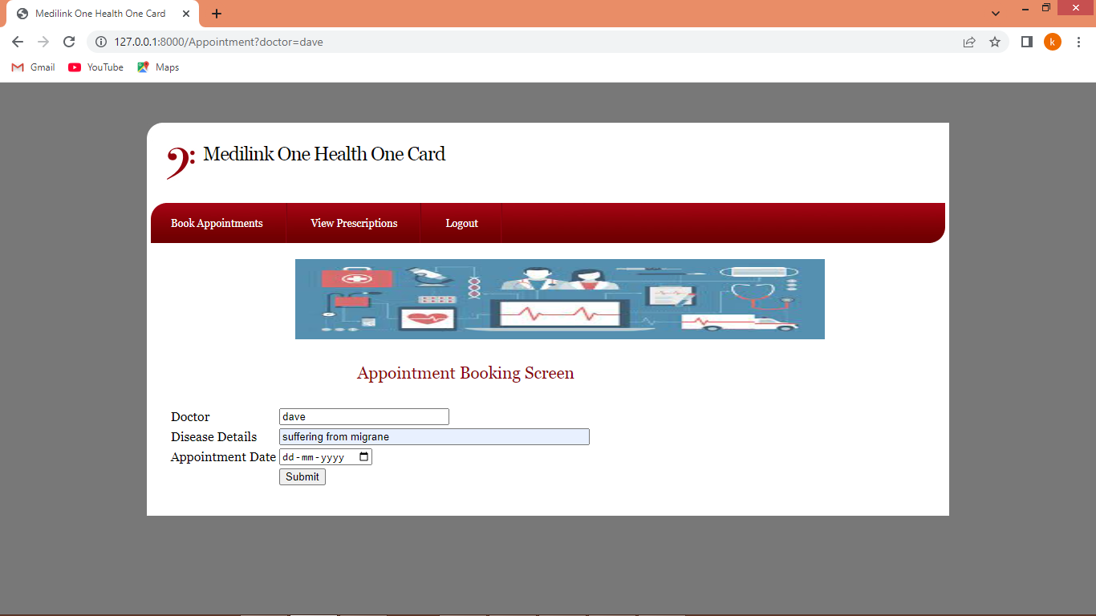
In above screen patient will enter some symptoms and then choose appointments date and then press button to complete appointment and get below page
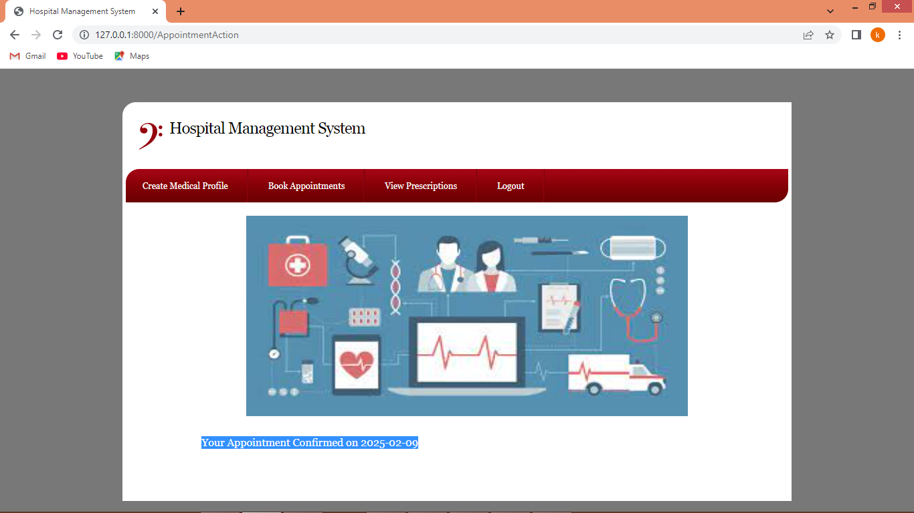
In above screen appointment is confirmed on selected date and now clicks on ‘View Prescription’ link to view generated prescription
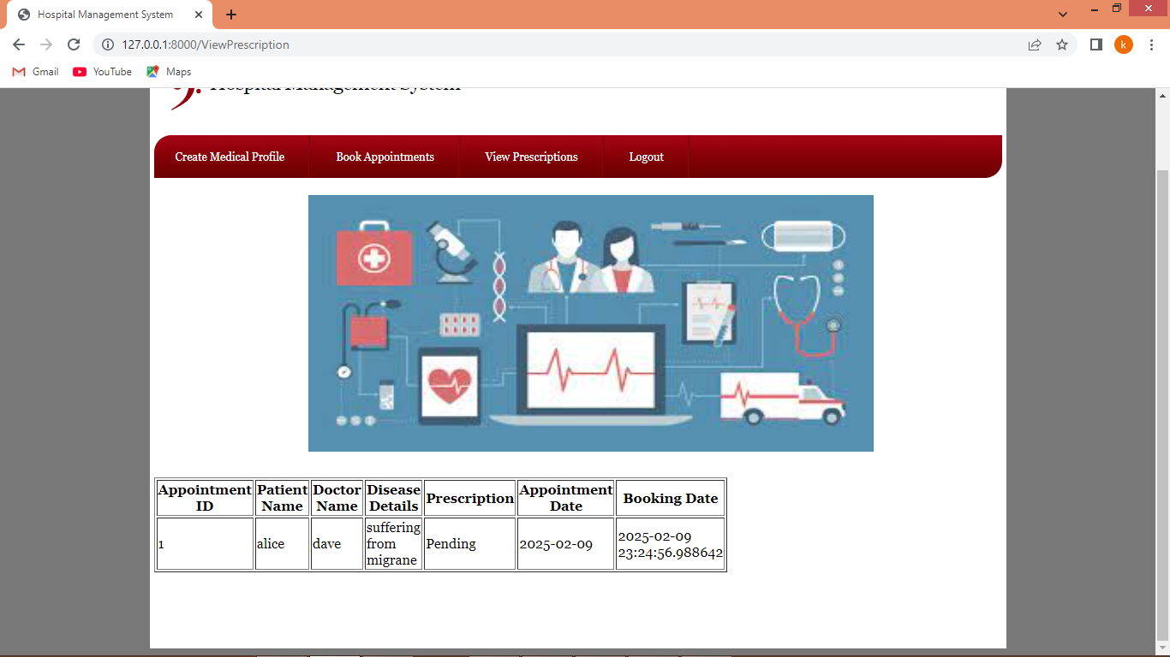
In above screen appointment is confirmed but prescription is pending as doctor not yet generated prescription. Now logout and login as doctor to generate prescription
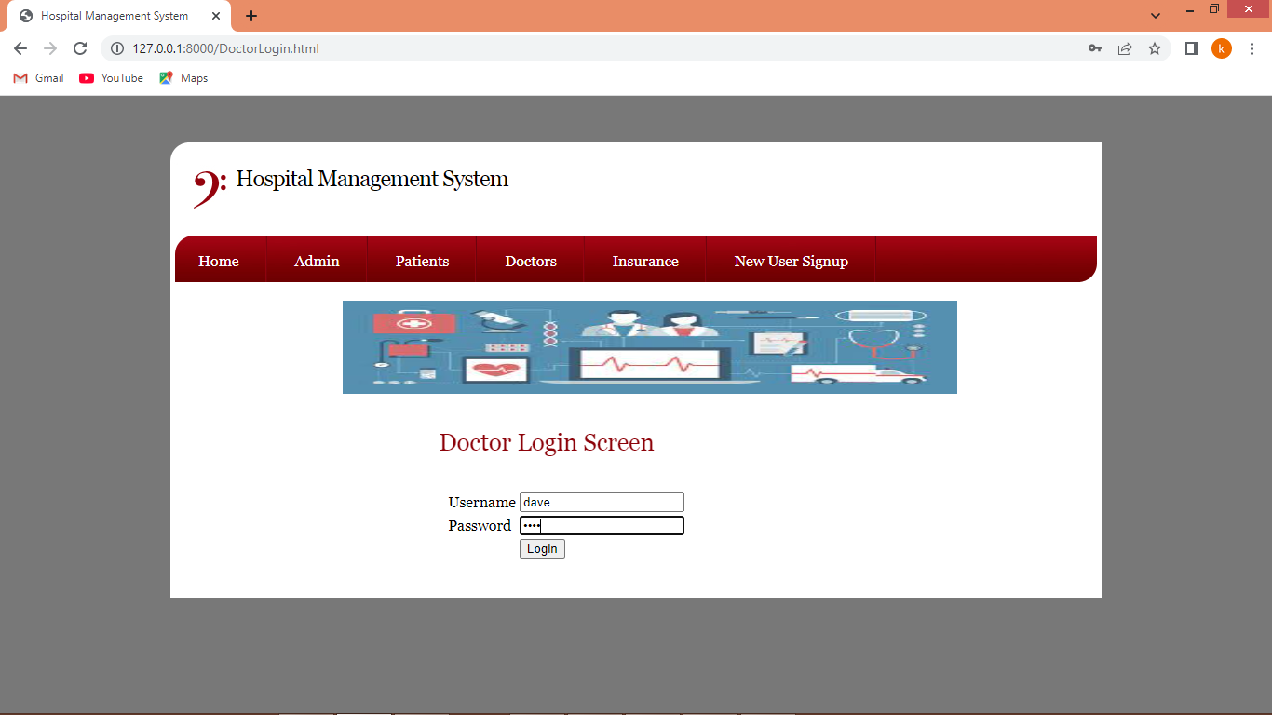
In above screen doctor is login and after login will get below page
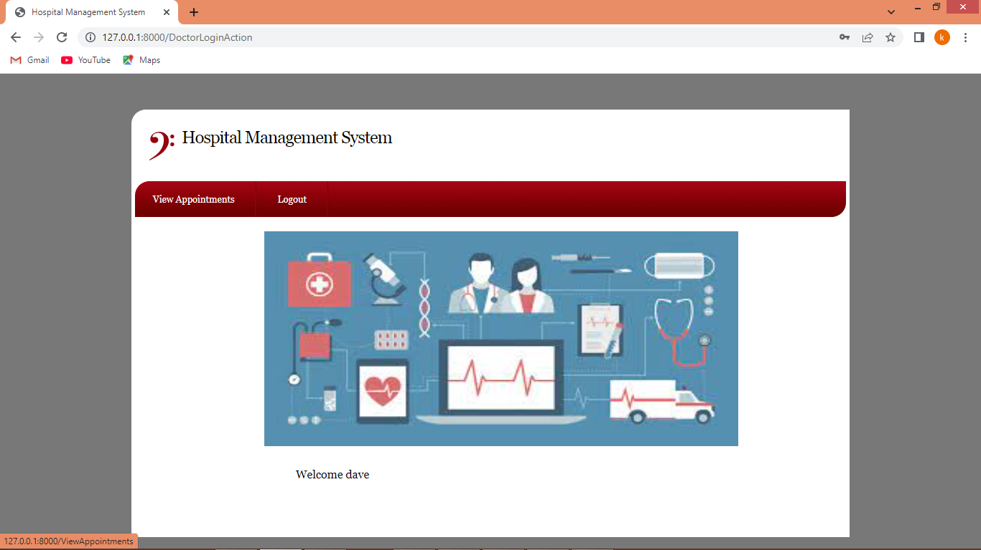
In above screen click on ‘View Appointment’ link to view all today’s appointment and get below page
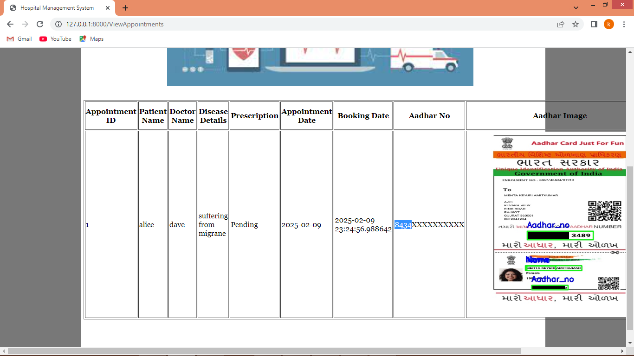
In above screen doctor can view all patient details related to appointment and can see Aadhar number on both plain text and on card is successfully masked with black colour and now in below screen you can click on ‘Generated Prescription’ link to generated prescription
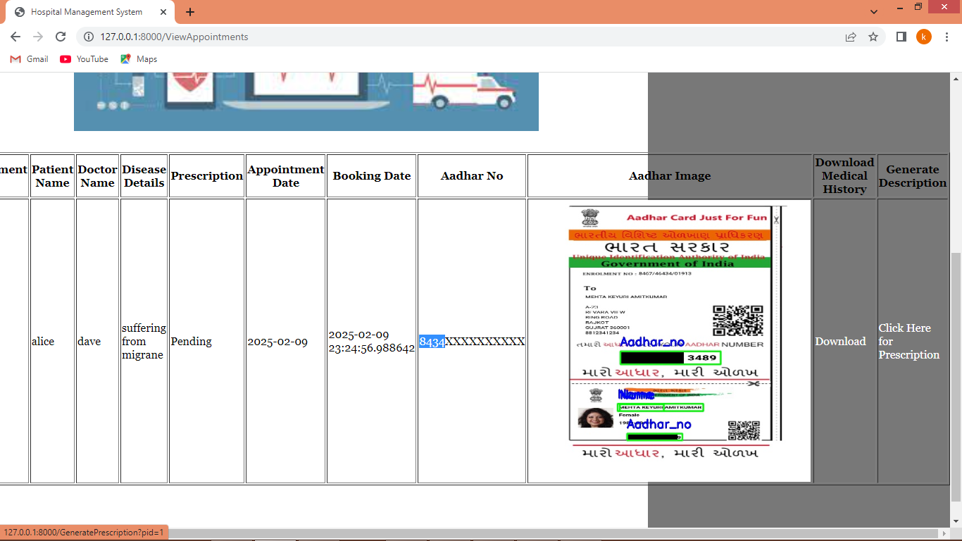
In above screen doctor can click on ‘Download’ link to download medical history document or can click on ‘Click Here for Prescription’ link to generate prescription
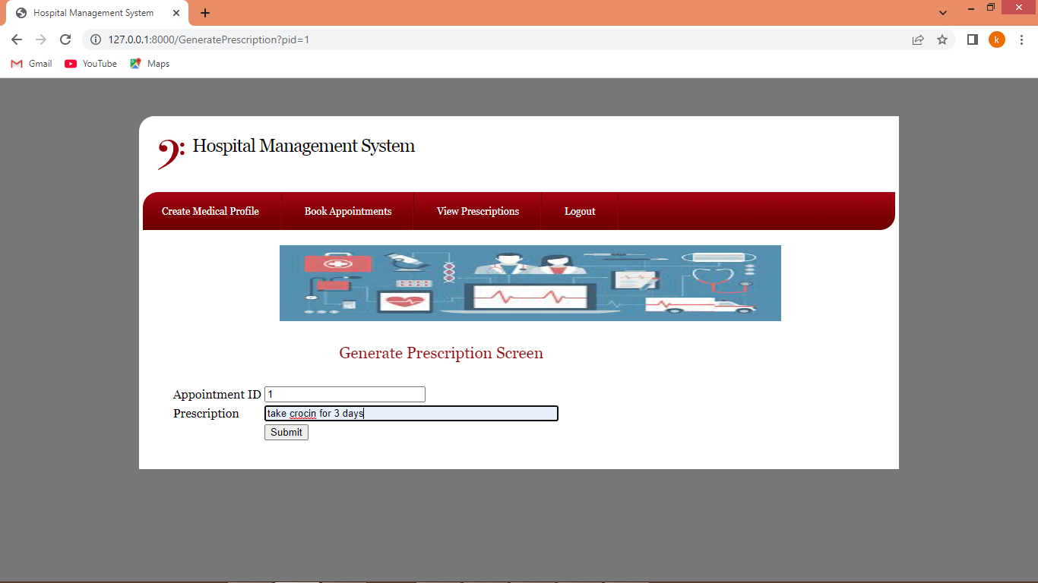
In above screen doctor will write some prescription and then press button to get below page
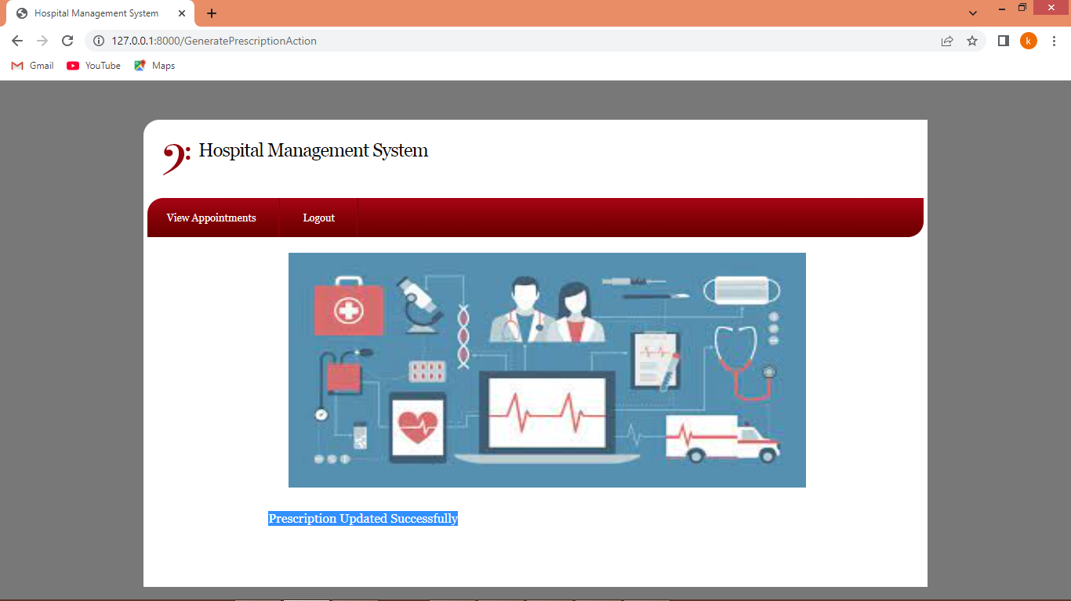
In above screen prescription successfully generated and now logout and login as ‘admin’ to view all profiles
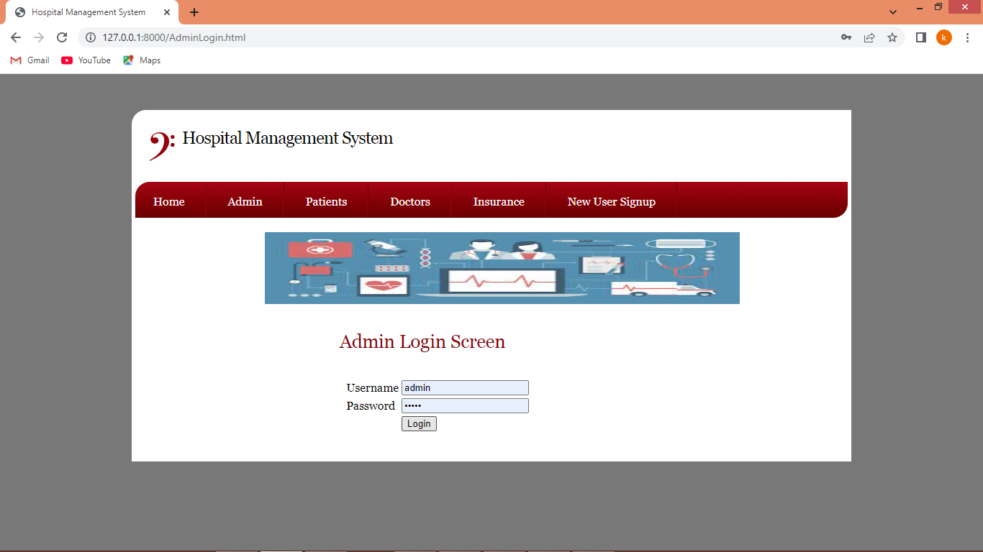
In above screen admin is login and after login admin will get below page
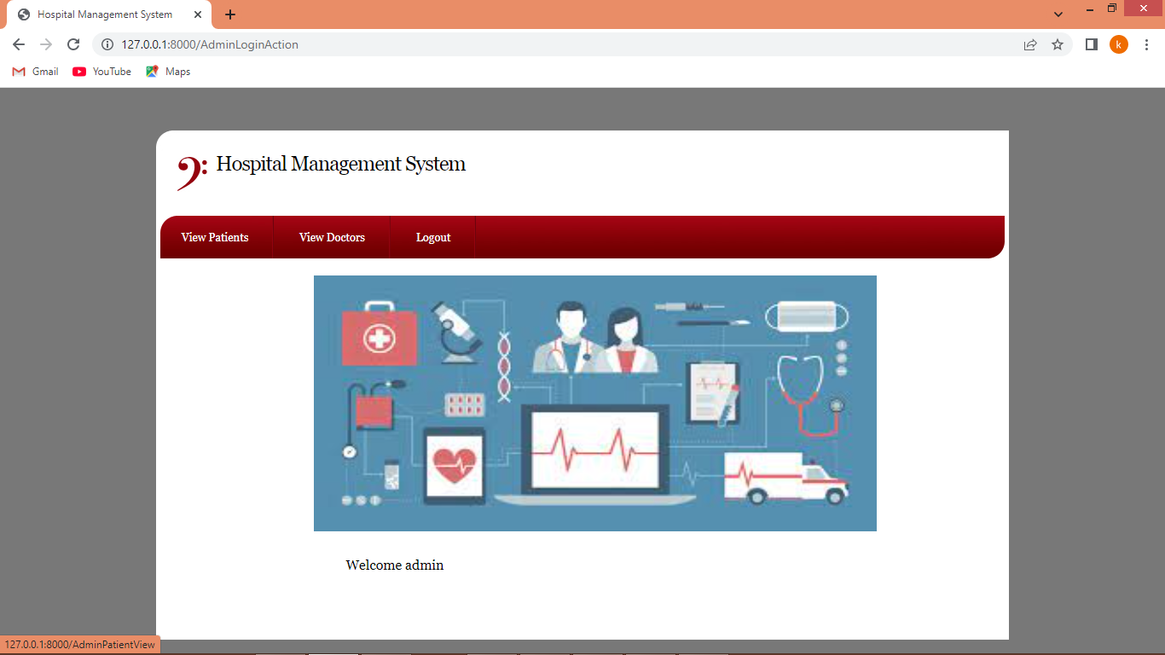
In above screen admin can click on ‘View Patients’ link to view all appointments
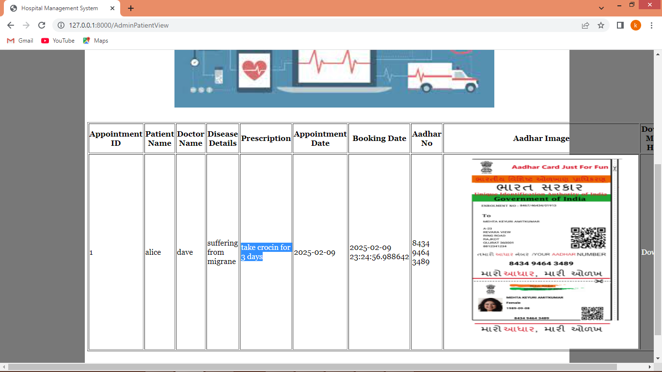
In above screen blue text admin can view ‘Prescription’ is generated and can see Aadhar card is unmasked and now click on ‘View Doctor’ link to view list of registered doctors
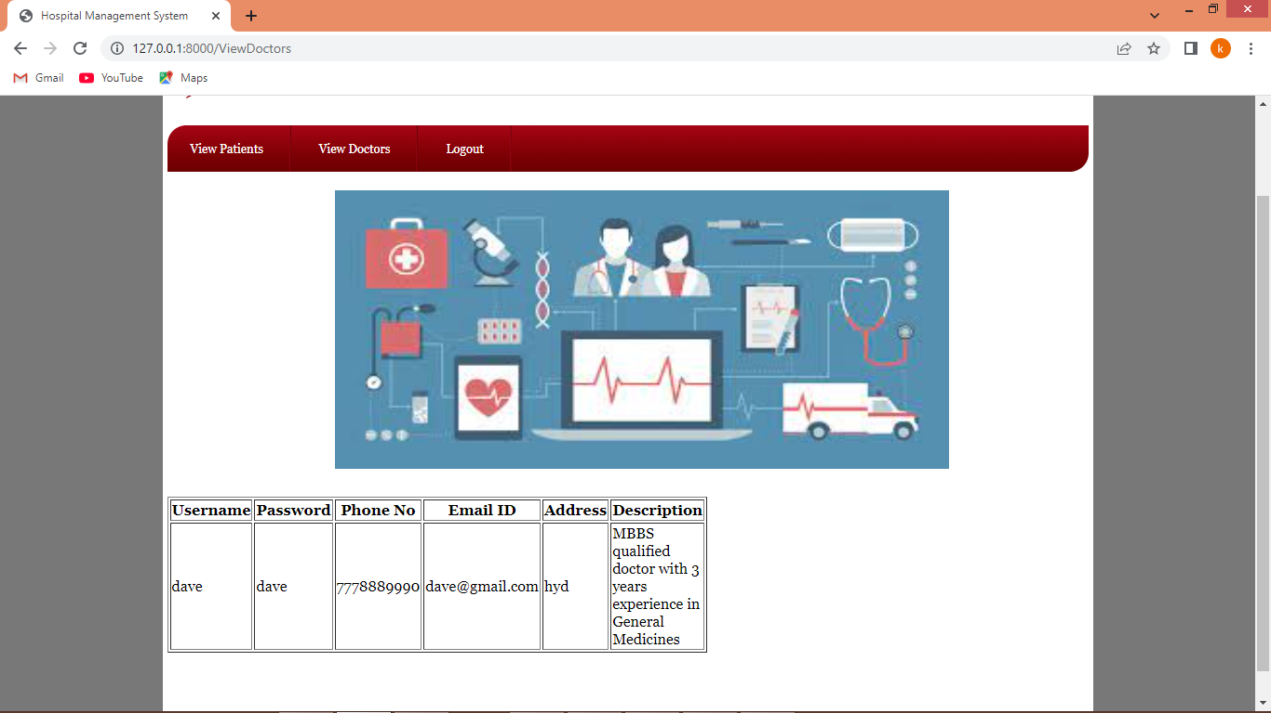
In above screen admin can view list of registered doctor list and now logout and login as insurance user
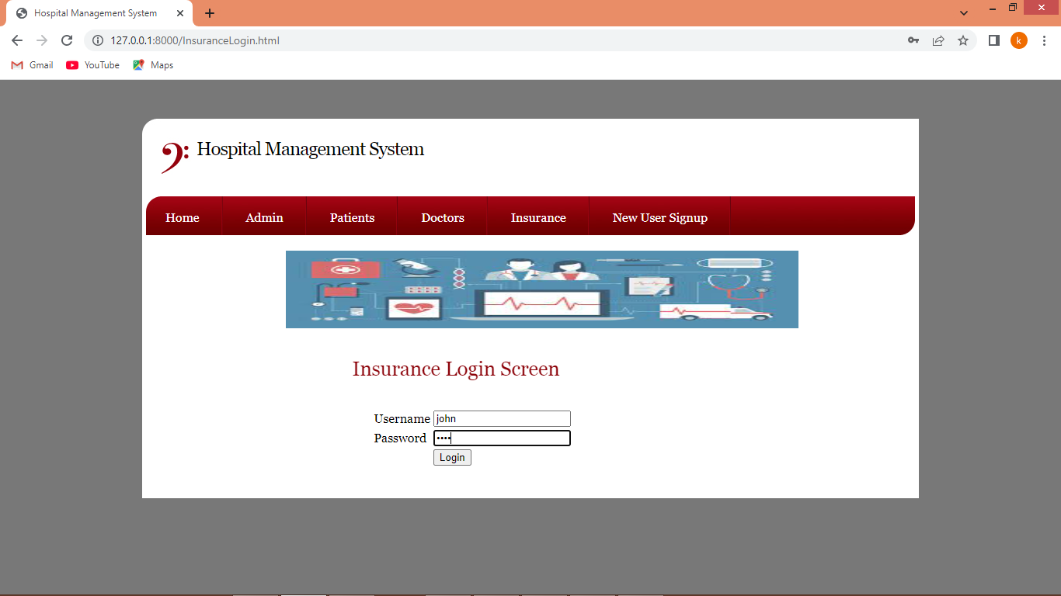
In above screen insurance user is login and after login will get below page
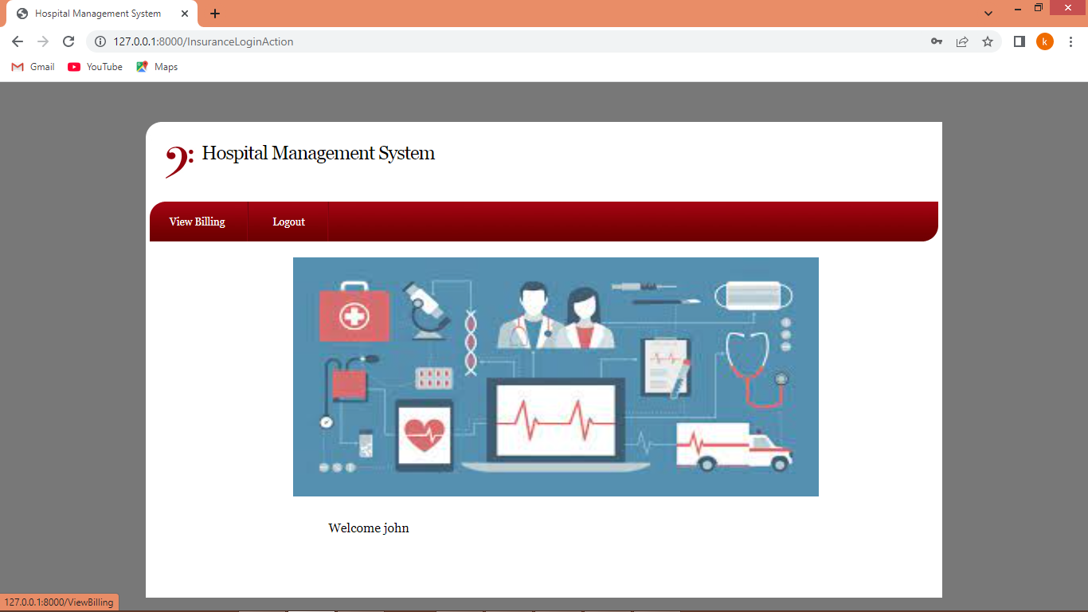
In above screen insurance user can click on ‘View Billing’ link to get below page
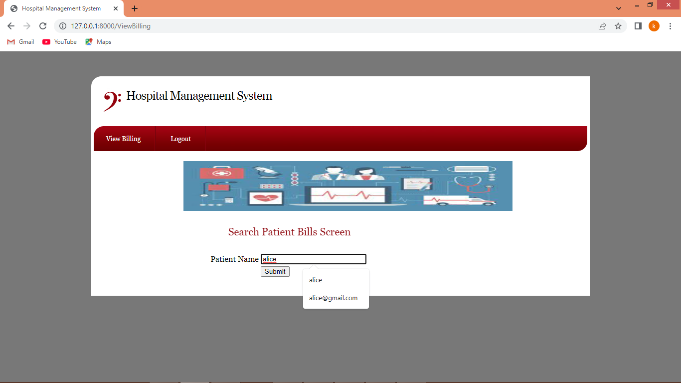
In above screen insurance user will enter patient name and then press button to get below page
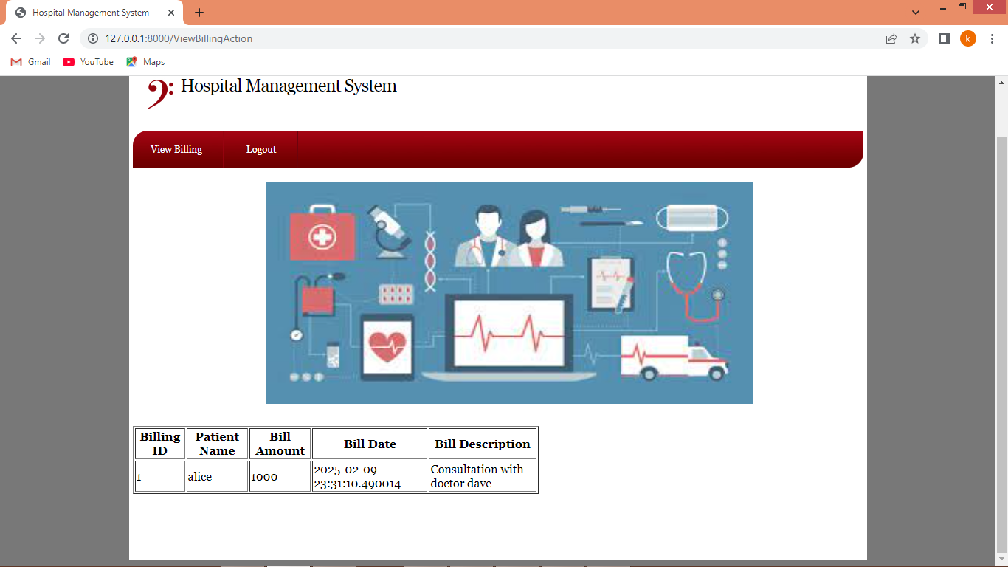
In above screen insurance user can view billing details.
Similarly by following above screens you can add as many users as you want. Below is the YOLO training performance graph
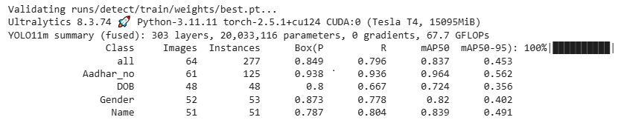
In above screen you can see precision of YOLO for each class prediction
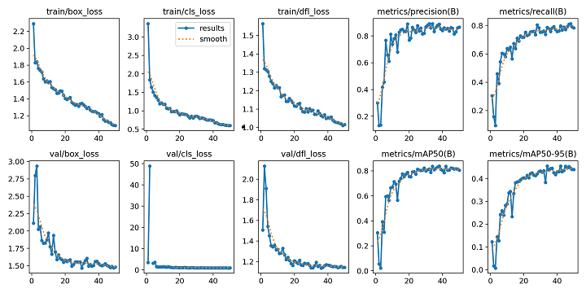
In above screen you can see YOLO training loss and precision graph where x-axis represents number of training epoch and y-axis represents loss and precision values and can see with each increasing epoch precision got increased and loss got decreased.
5.CONCLUSION:
With the electronic entry of patient information into the Hospital Management System, data security is ensured. By utilizing this application, we can effortlessly access a patient's medical history with just a single click. Thus, processing information will be faster. It guarantees accurate maintenance of process, the Hospital Management System significantly diminishes the burden of manual tasks, thereby minimizing human effort and enhancing both accuracy and The Hospital Management System plays a vital role in maintaining comprehensive information about doctors, patients, hospital staff, and more. It is evident that the utilization of the Hospital Management System project greatly simplifies work processes, making them more efficient and user Management System, hospital administrators can achieve substantial enhancements in operational control, leading to the efficient streamlining of various hospital and retrieval through the Hospital Management System enables healthcare providers to enhance their response time to patient care needs, thereby improving overall efficiency. Accounting sometimes becomes awfully pathetic and complex. This product will eliminate any such complexity.
FUTURE SCOPE

1. Blockchain-Based Medical Records
- Secure, tamper-proof patient data storage.
- Enables safe record sharing across multiple hospitals.

2. Chatbot for Patient Assistance
- 24/7 virtual assistant for guiding patients
- Help with appointments, FAQs, doctor availability, and prescription info.

3. Voice-Based Data Entry System
- Doctors or nurses can enter records using voice commands
- Reduces time and improves accuracy.

4. Face Recognition for Patient/Staff Login
- Faster and more secure authentication system.
- Avoids password-related issues.

5. RFID-Based Patient Tracking
- Real-time tracking of patient movement inside the hospital.
- Useful for emergency departments and large hospitals.

REFERENCES:
- R. Beri, M. K. Dubey, A. Gehlot, and R. Singh, “Health Assessment Model to Identify and Control Risk Associated with Preeclampsia using IoT,” in ICRITO 2020 - IEEE 8th International Conference on Reliability, Infocom Technologies and Optimization (Trends and Future Directions), 2020, pp. 421–425, doi: 10.1109/ICRITO48877.2020.9197786.
- Rana, A. S. Rawat, H. Bahuguna, and A. Bijalwan, “Application of multi-layer neural network in medical diagnosis: An efficient survey,” Int. J. Eng. Technol., vol. 7, no. 3.34 Special Issue 34, pp. 493–494, 2018.
- Awasthi, N. Hothi, P. Kaur, N. Singh, M. Chakraborty, and S. Bansal, “Elucidative analysis and sequencing of two respiratory health monitoring methods to study the impact of varying atmospheric composition on human health,” Atmos. Environ., vol. 171, pp. 32–37, 2017, doi: 10.1016/j.atmosenv.2017.10.008.
- S. Jacob al. An adaptive and flexible brain energized full body exoskeleton with iot edge for assisting the paralyzed patients. in IEEE Access, 8 : 721–10073, 2020.
- IliasMaglogiannis CharalamposDoukas. Bringing iot and cloud computing towards pervasive healthcare. In Sixth International Conference on Innovative Mobile and Internet Services in Ubiquitous Computing, pages 978–0. P.P-7695-4684-1/12, 2012
- Dalia Kamal A. A. Rizk, Hoda M. Hosny, and El-Sayed M. El-Horbaty, “SMART Hospital Management Systems Based on the Internet of Things: Challenges, Intelligent Solutions, and Functional Requirements,” International Journal of Intelligent Computing and Information Sciences IJICIS, Vol. 22, No. 1, 32–43.
- M. Alhussein, G. Muhammad, M S. Hossain, SU. Amin, and A. Rahman, “Cognitive Smart Healthcare for Pathology Detection and Monitoring,” In: IEEE Access, 2019, p. 10745–10753.
- Gunjan Yadav, Parth Lad, Parul Pandey, Tejaswi Kolla, Advanced Hospital Database Management System,[Internet].
- Yang, G. ; Pang, Z. ; Deen, J. ; Dong, M. ; Zhang, Y.-T. ; Lovell, N. ; Rahmani, A.M. Homecare Robotic Systems for Healthcare 4.0: Visions and Enabling Technologies. IEEE J. Biomed. Health Inform.
- Liang, C. ; Gu, D. ; Tao, F. ; Jain, H.K. ; Zhao, Y. ; Ding, B. Influence of mechanism of patient-accessible hospital information system implementation on doctor-patient relationships: A service fairness perspective.
- M. Alhussein, G. Muhammad, M S. Hossain, SU. Amin, Cognitive IoT-Cloud Integration for Smart Healthcare system.
- Hospital management system using web technology ISSN 0193 4120, May 2020 : Kotapati Saimanoj, Grandhi.

